**Task on Load Balancers**

**1.Configure Classic Load balancer.**

**Task Title**

**Configure a Classic Load Balancer in AWS**

**Objective**

**Set up a Classic Load Balancer to distribute HTTP traffic across EC2 instances hosted in multiple Availability Zones.**

**Prerequisites**

**• VPC  
• Public Subnets in at least 2 AZs  
• EC2 Instances with web server installed  
• IAM Role (if logs or S3 access needed)  
• Key Pair  
• Security Groups for EC2 & ELB  
• Route Tables properly associated  
• AMI (Amazon Linux 2 image)**

**Step-by-Step Implementation (With Evidence)**

**Step 1: Launch two EC2 instances**

**Console Path:  
EC2 → Instances → Launch Instance**

**Actions:  
• Choose Amazon Linux 2  
• Select public subnet (AZ-A and AZ-B)  
• Assign security group allowing port 80  
• Add user data to install web server**

**User Data:**

#!/bin/bash

yum install -y httpd

echo "Server $(hostname) — Classic Load Balancer Test" > /var/www/html/index.html

systemctl start httpd

systemctl enable httpd

**Evidence:  
• Screenshot of Instances page showing running state**

**Public-ec2-1  
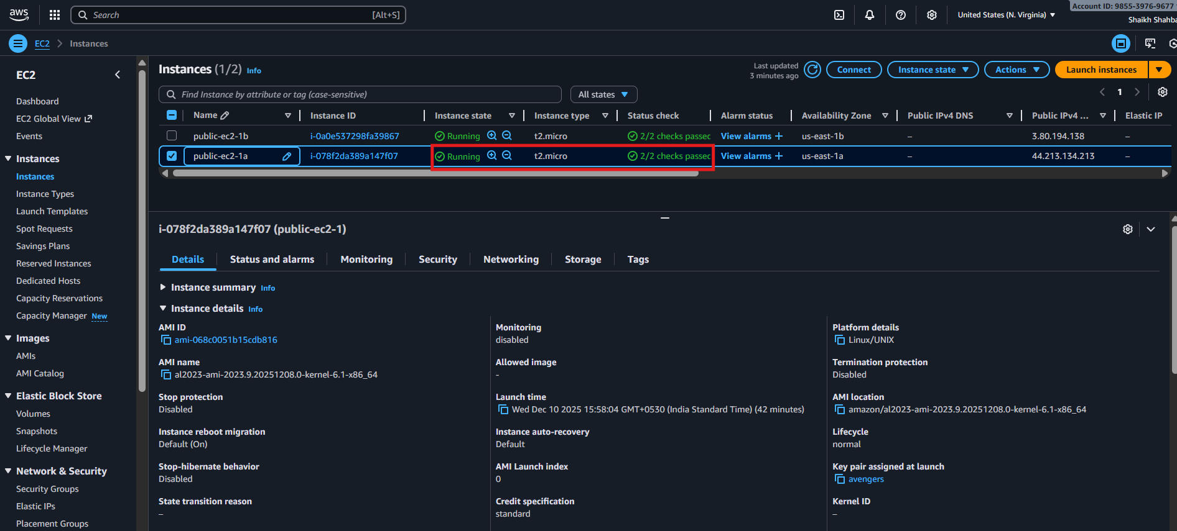**

**Public-ec2-1b**

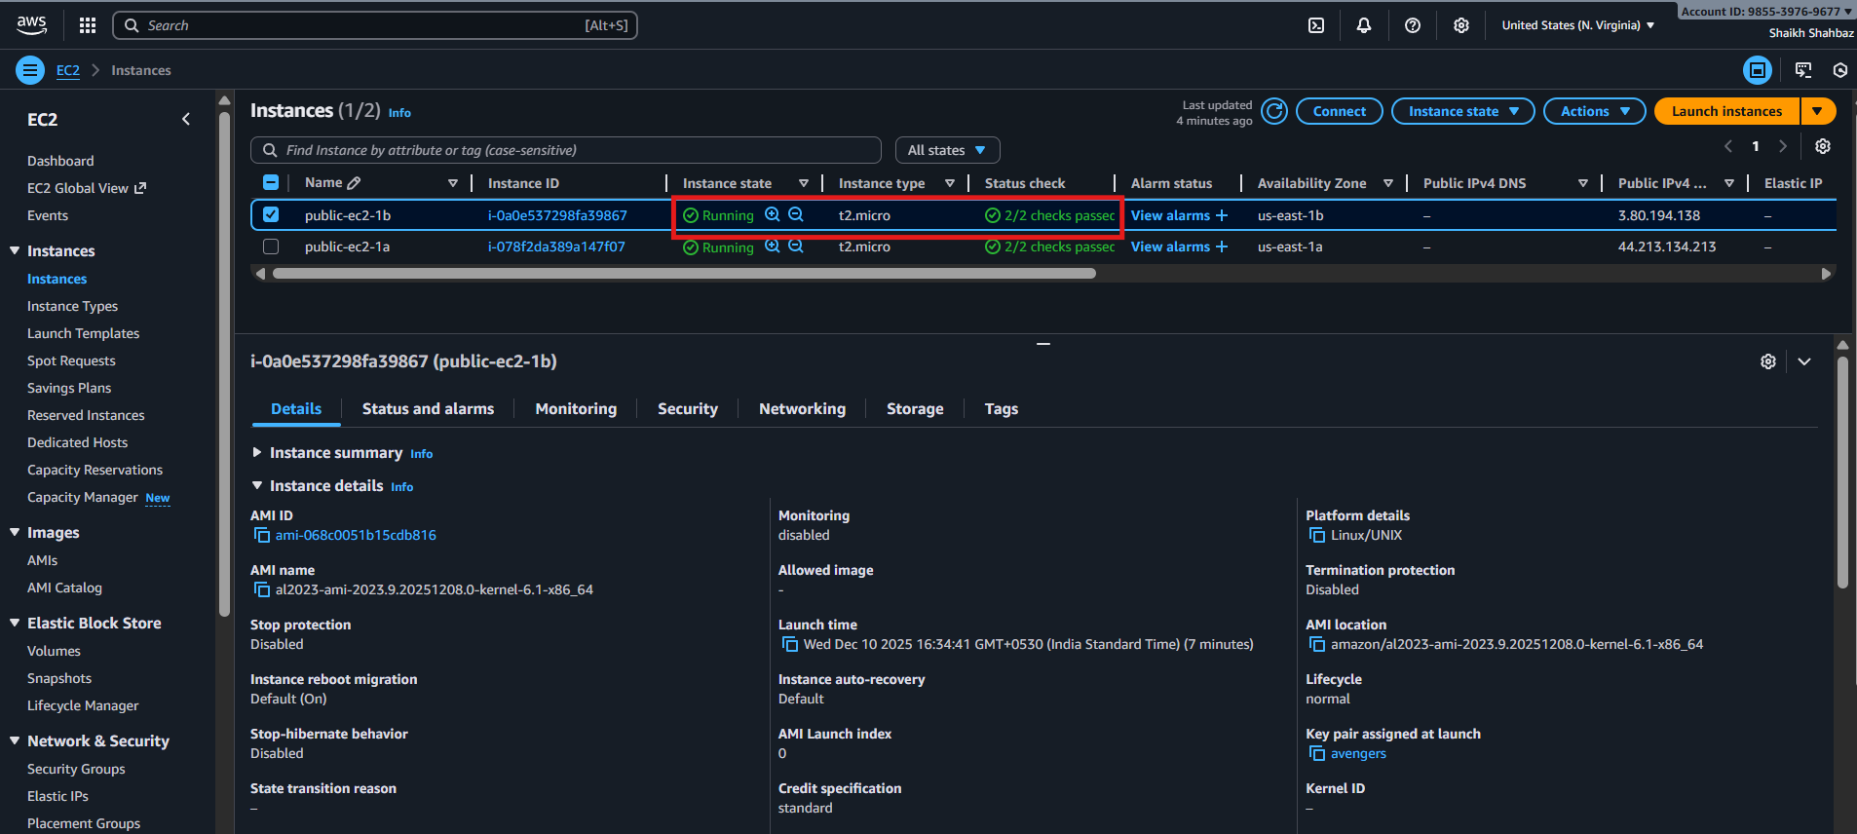

**Evidence:  
• Browser screenshot loading the page**

**Public-ip of ec2-1a :**

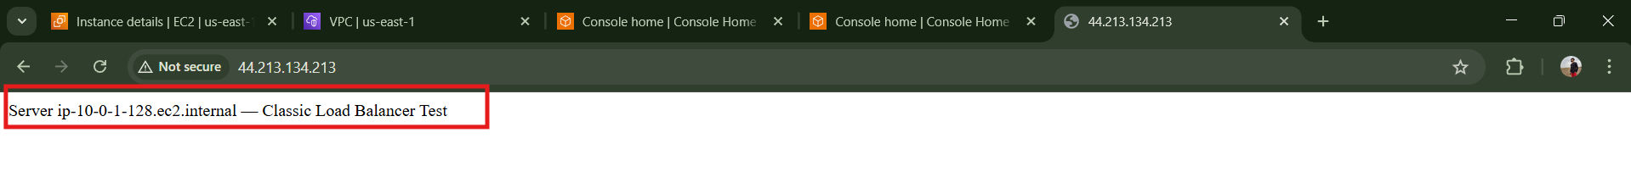

**Public-ip of ec2-1b :**



**Step 3: Create Classic Load Balancer**

**Console Path:  
EC2 → Load Balancers → Create Load Balancer → Classic Load Balancer**

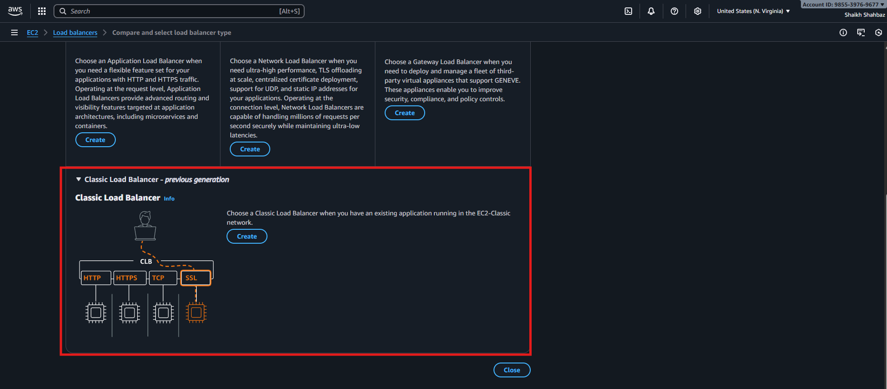

**Actions:  
• Name: classic-lb-demo  
• Scheme: internet-facing  
• Listener: HTTP 80 → 80  
• Select 2 public subnets  
• Select ELB security group (allow 80)**

**Evidence:  
• Screenshot of CLB creation wizard  
• Screenshot of listener configuration**

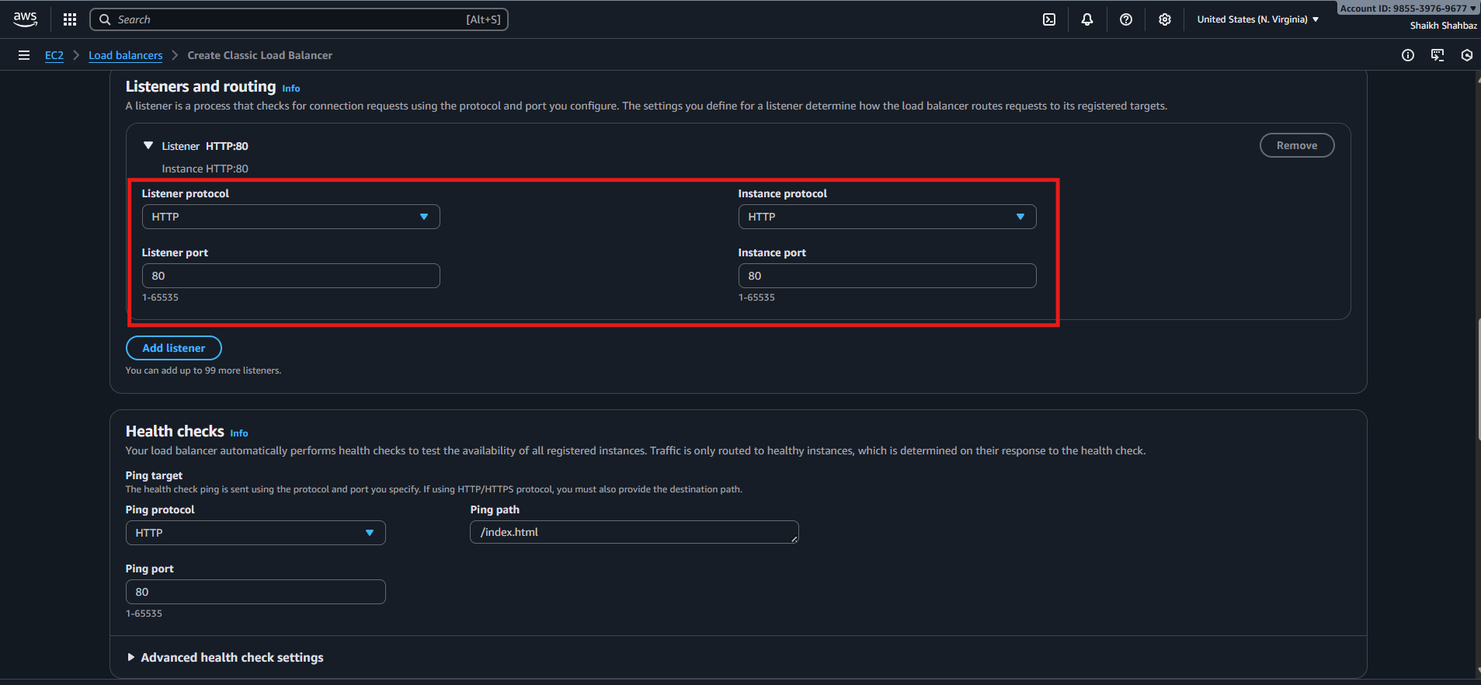

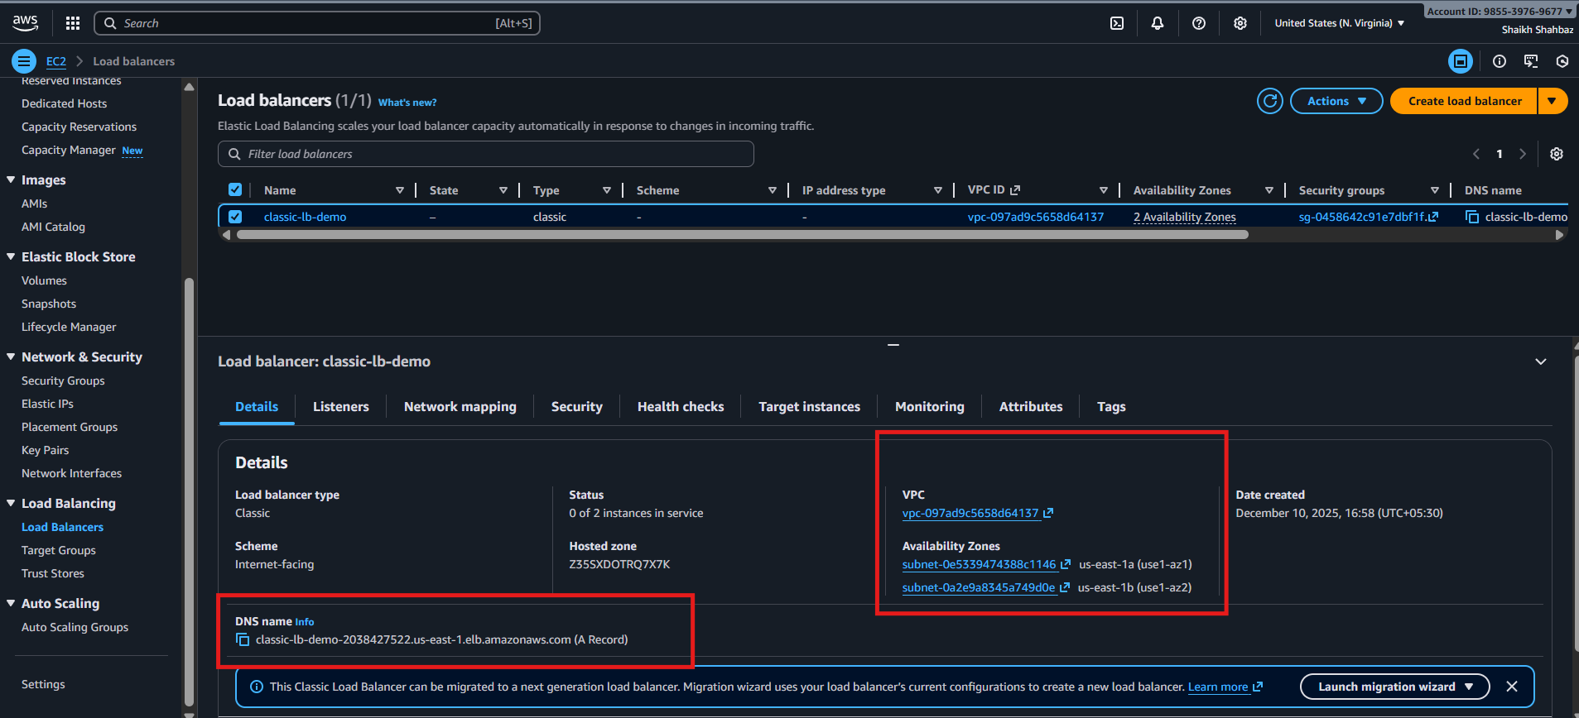

**Step 4: Configure Health Checks**

**Settings:  
• Ping Protocol: HTTP  
• Ping Path: /  
• Response Timeout: 5 seconds  
• Healthy Threshold: 3  
• Unhealthy Threshold: 2**

**Evidence:  
• Screenshot of health check configuration page**

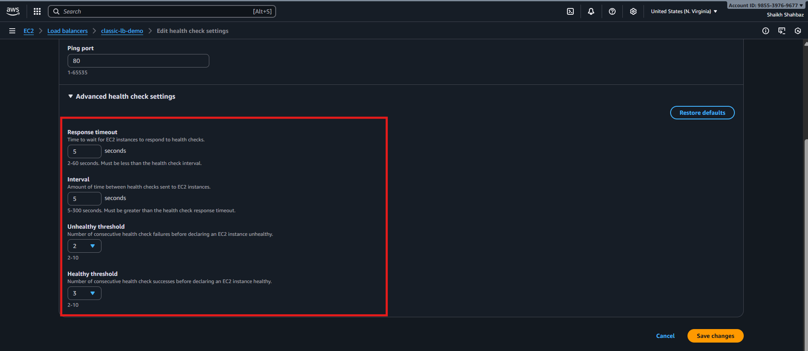

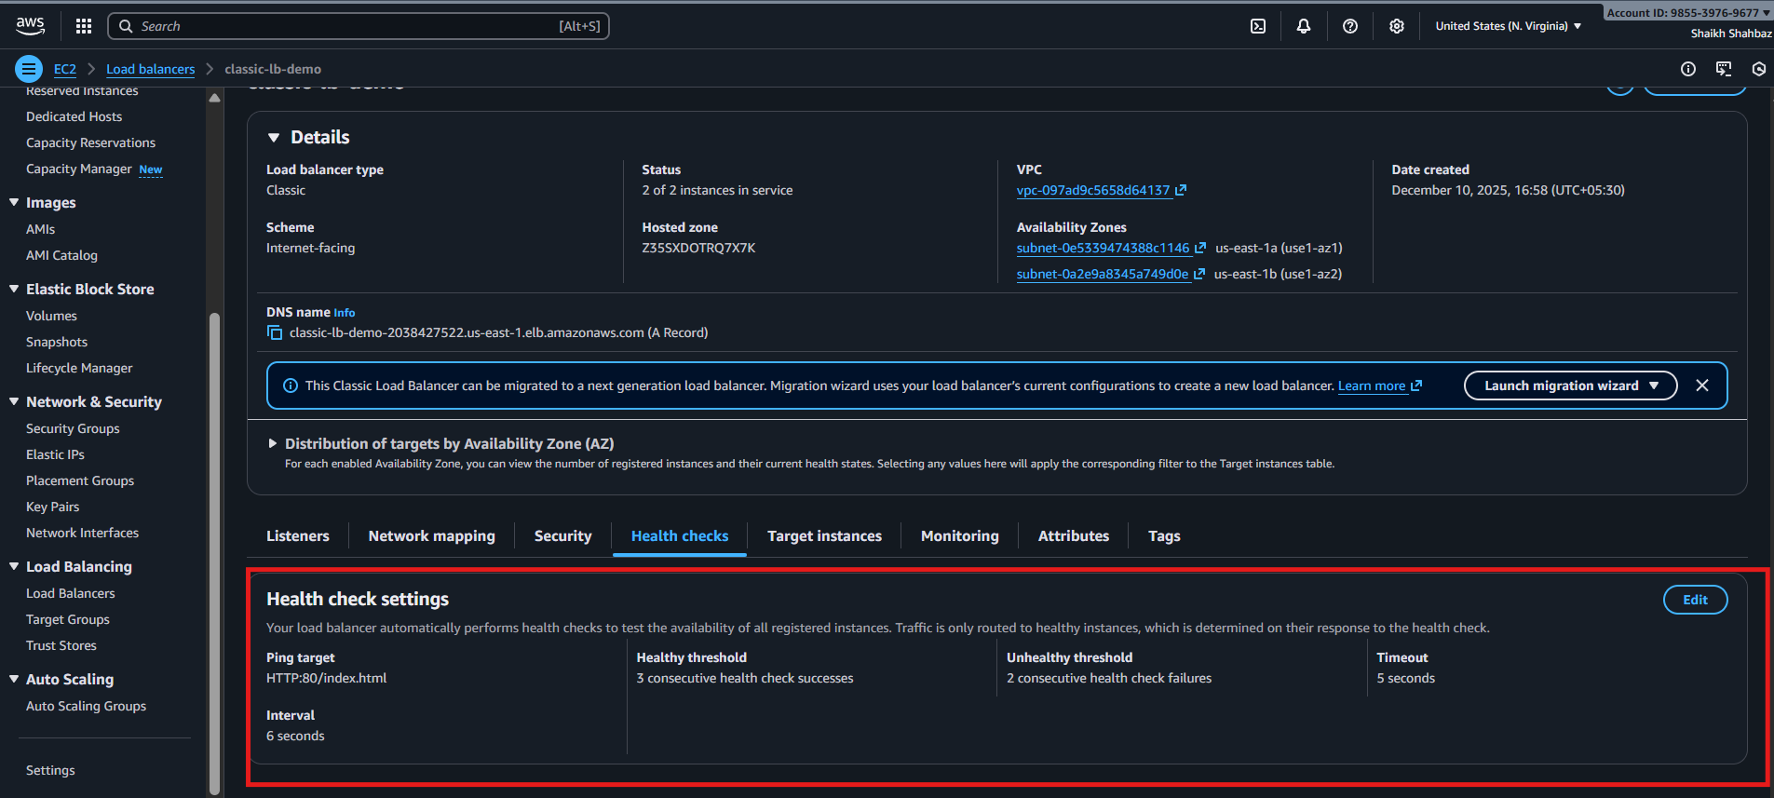

**Step 5: Register EC2 Instances**

**Console Path:  
Add both EC2 instances to Registered Instances**

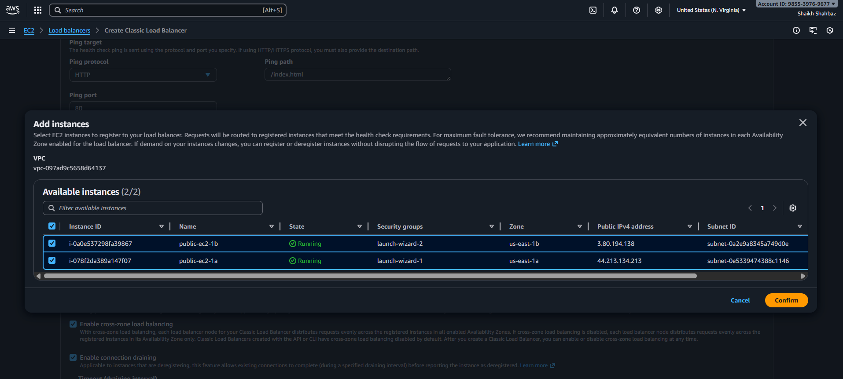

**Explanation:  
CLB starts performing health checks and changes state to InService.**

**Evidence:  
• Screenshot showing EC2 instances as "InService" under CLB**

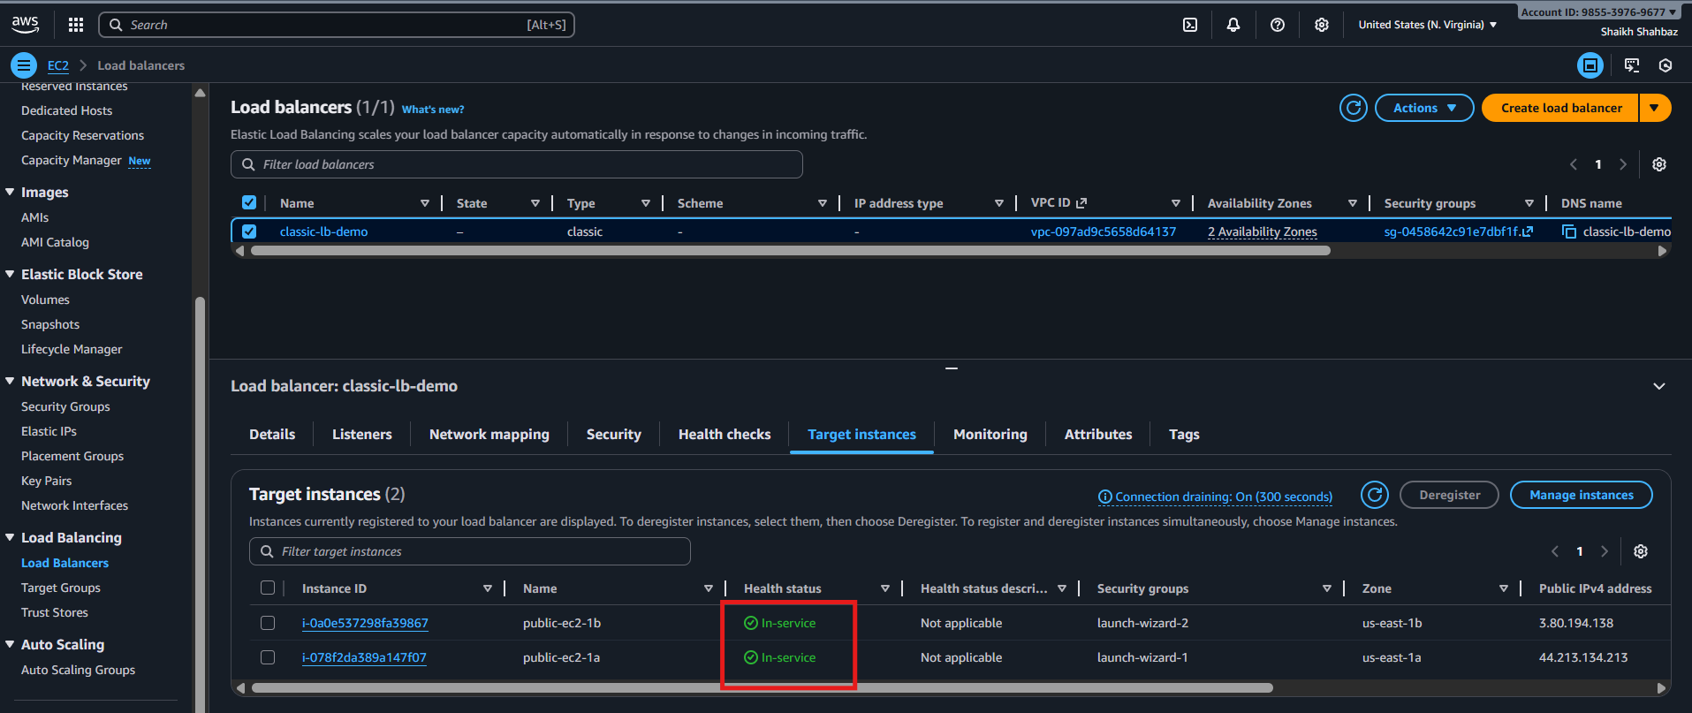

**Validation Steps (Mandatory, With Evidence)**

**Validation 1: Resource Health**

**Check instance status:  
• 2/2 checks passed  
• InService under CLB**

**Evidence:  
Screenshot: EC2 status checks + CLB registered targets**



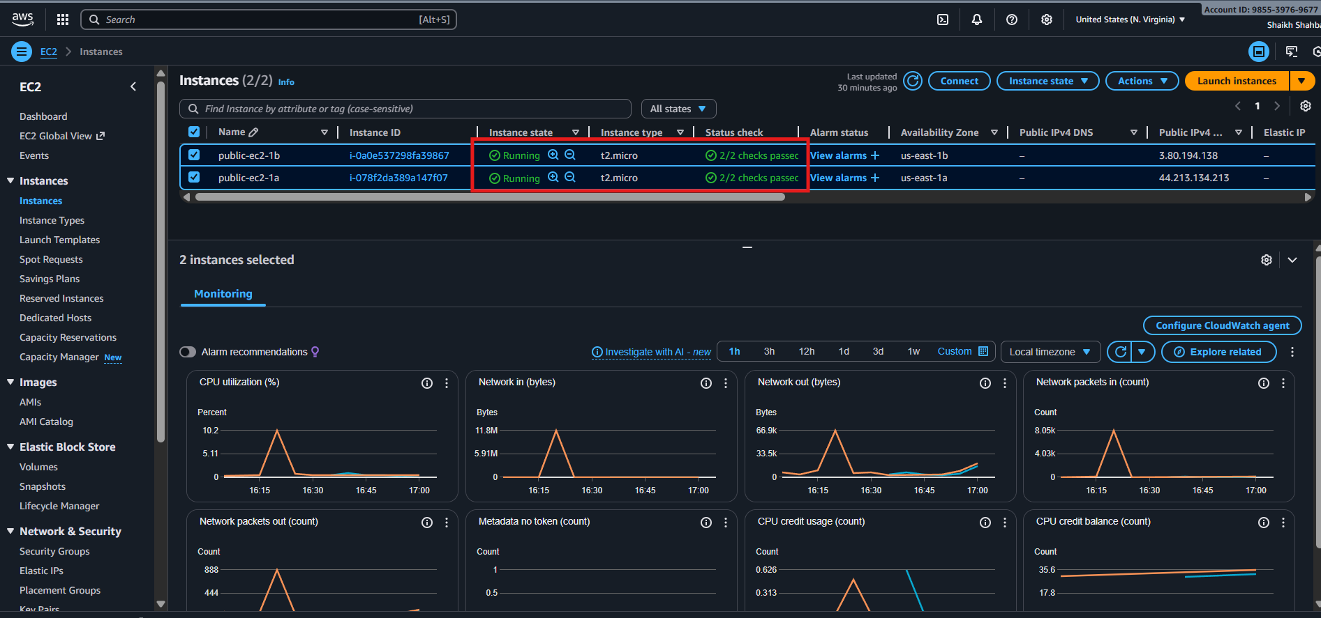

**Validation 2: Functional Check**

**Open:**

**http://** **classic-lb-demo-2038427522.us-east-1.elb.amazonaws.com**

**Refresh multiple times → responses alternate:**

**Evidence:  
• Browser screenshot showing both server responses**

**Server ip-xx-xx-xx-xx — CLB Test**

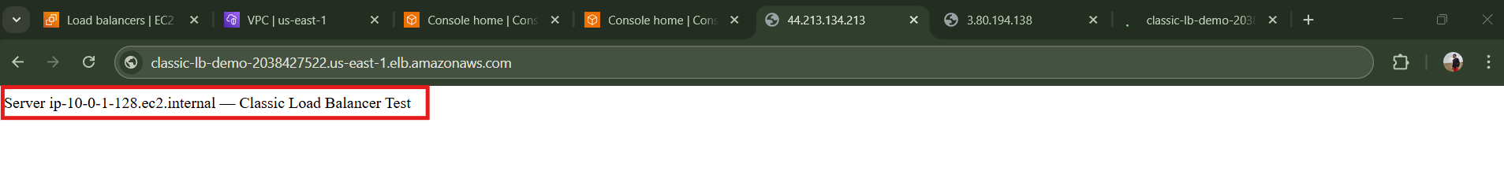

**Server ip-yy-yy-yy-yy — CLB Test**

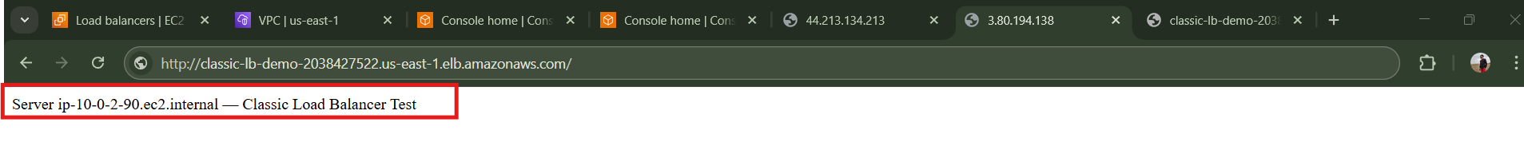

**Validation 3: Network Check**

**SSH to instance:**

**curl http://localhost**

**Expected output from Apache server.**

**Evidence:  
Terminal screenshot.**

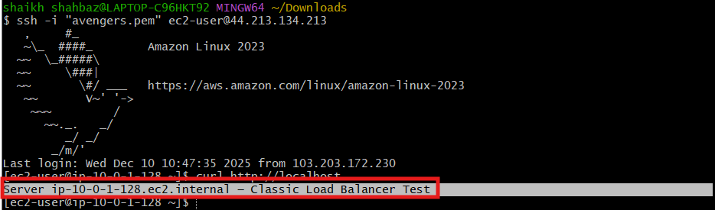

**Issues Faced (Optional)**

**• Sometimes CLB shows "OutOfService" due to incorrect security group  
Fix: Allow port 80 from the ELB security group to EC2 instances.**

**• If using custom AMI, Apache may fail to start  
Fix: Verify user data executed correctly in /var/log/cloud-init-output.log.**

**Conclusion**

**Classic Load Balancer successfully configured to distribute HTTP traffic across EC2 instances, with verified health checks, network connectivity, and functional access.**

**2.Configure Application Load balancer.**

**Task Title**

**Configure Application Load Balancer (ALB)**

**Objective**

**Create an Application Load Balancer to distribute HTTP/HTTPS traffic across multiple EC2 instances using Layer 7 intelligent routing.**

**Prerequisites**

**Before starting, ensure the following are ready:**

* **VPC**
* **Public Subnets (min 2)**
* **IAM Role (EC2 Role – optional)**
* **Key Pair**
* **Security Groups (Allow HTTP/HTTPS)**
* **EC2 Instances (Web server installed)**
* **Route Tables configured**
* **Packages Installed (Apache/Nginx)**
* **Internet Gateway attached to VPC**

**Step-by-Step Implementation (With Evidence)**

**Step 1: Launch 2 EC2 Instances**

**Console Path:**

**EC2 → Instances → Launch Instance**

**Actions:**

* **Choose Amazon Linux 2**
* **Select Instance Type: t2.micro**
* **Put each instance in a different Availability Zone**
* **Install Apache on each instance:**

**sudo yum install -y httpd**

**sudo systemctl start httpd**

**sudo bash -c 'echo "Server $(hostname) responding through ALB" > /var/www/html/index.html'**

**Evidence (expected output):**

* **Apache running**

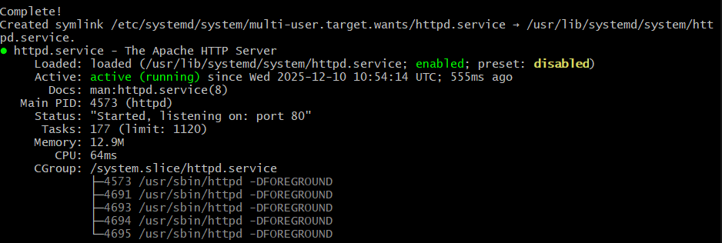

* **Screenshot should show EC2 Status: Running + 2/2 Status Checks Passed**

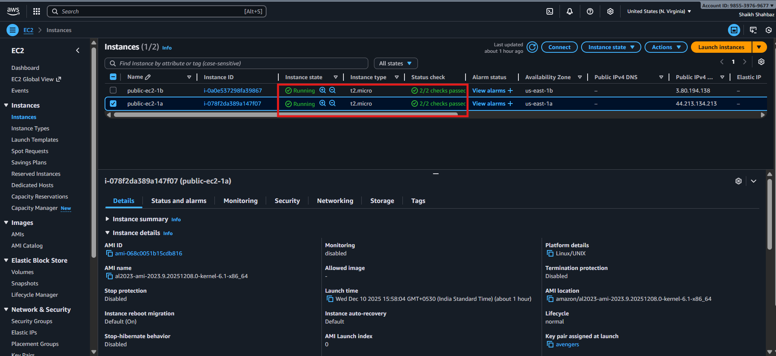

**Step 2: Create a Target Group**

**Console Path:**

**EC2 → Target Groups → Create Target Group**

**Actions:**

* **Choose Instance target type**
* **Protocol: HTTP**
* **Port: 80**
* **Health Check Path: /**

**Register Targets:**

* **Select both EC2 instances**
* **Click Include as pending below → Create**

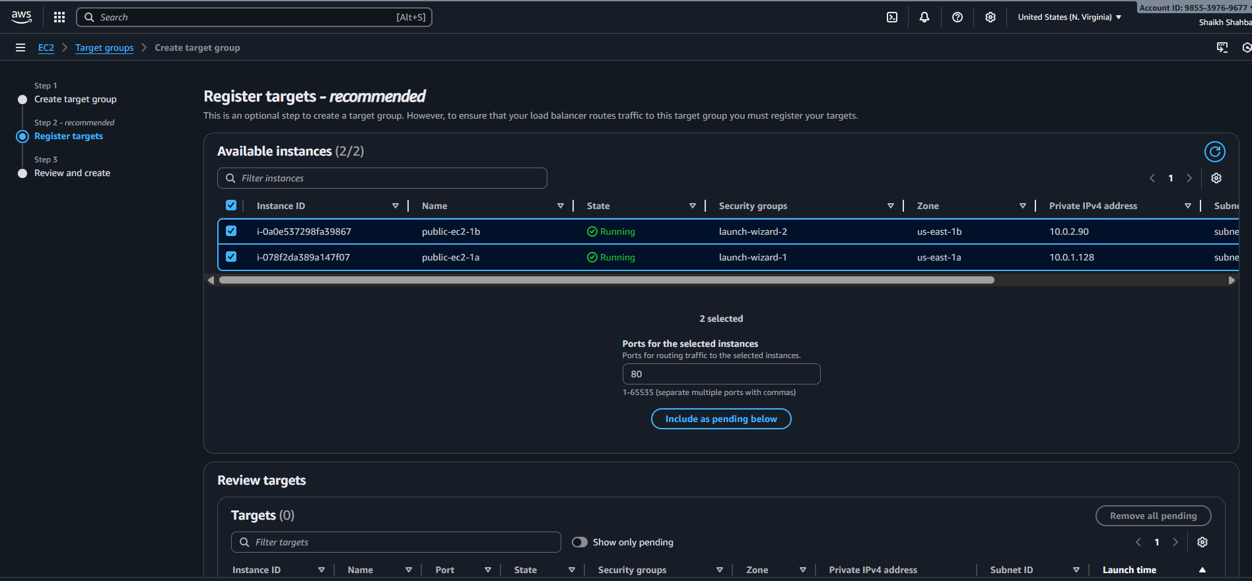

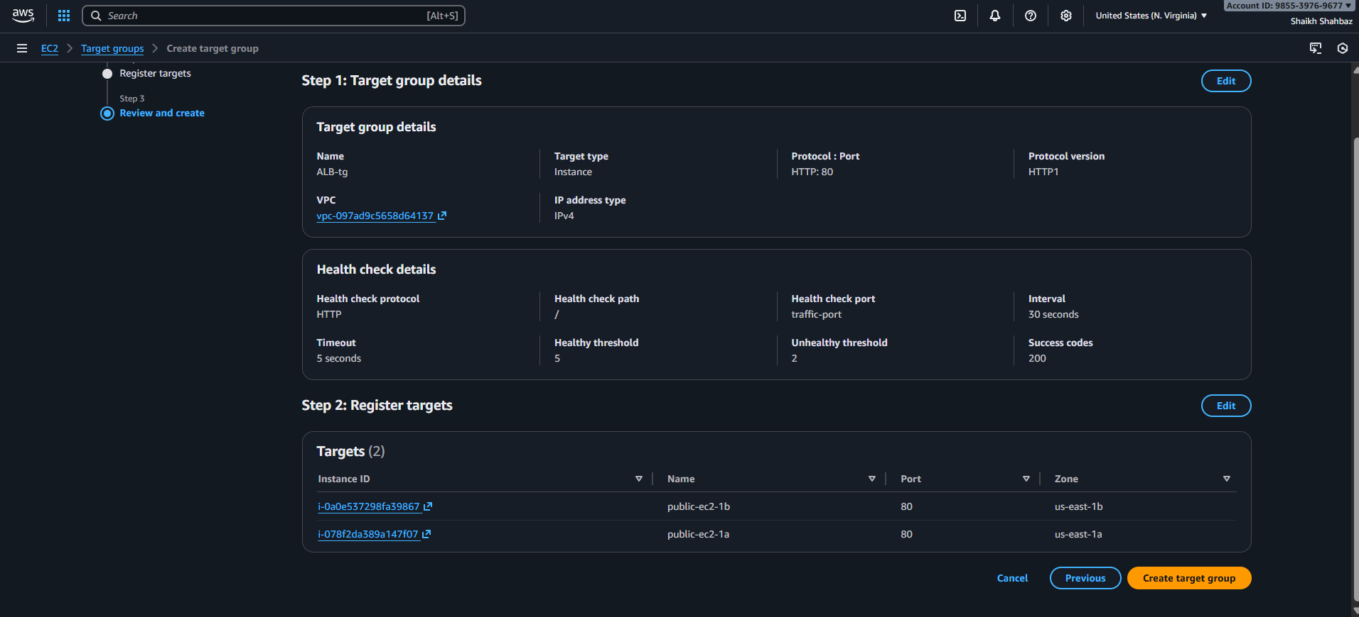

**Evidence:**

* **Target Health: initial → healthy**
* **Screenshot: Both EC2 instances showing healthy**

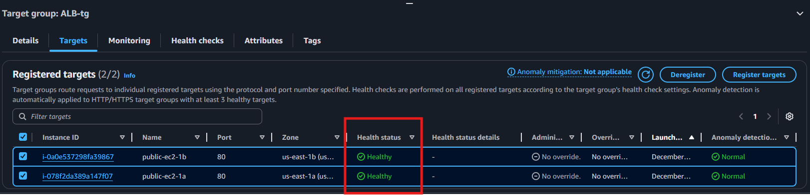

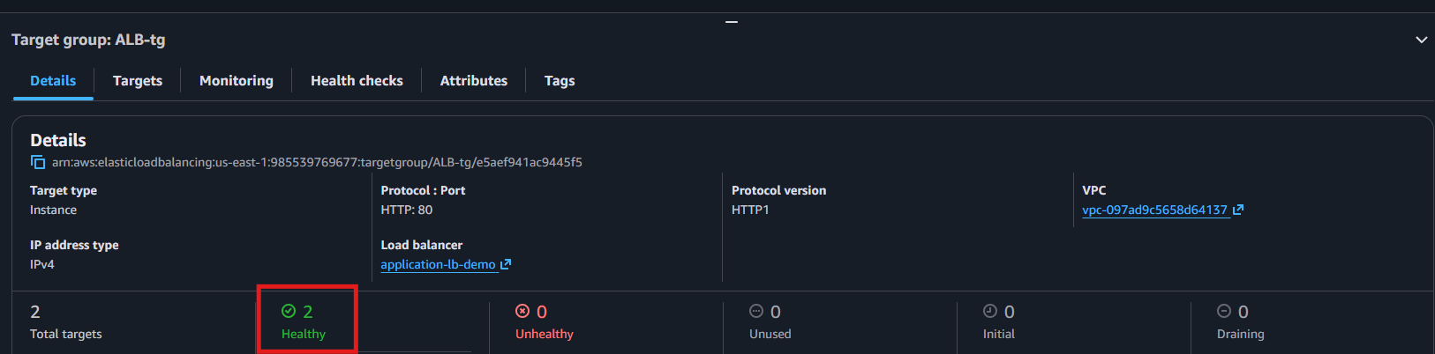

**Step 3: Create the Application Load Balancer**

**Console Path:**

**EC2 → Load Balancers → Create Load Balancer → Application Load Balancer**

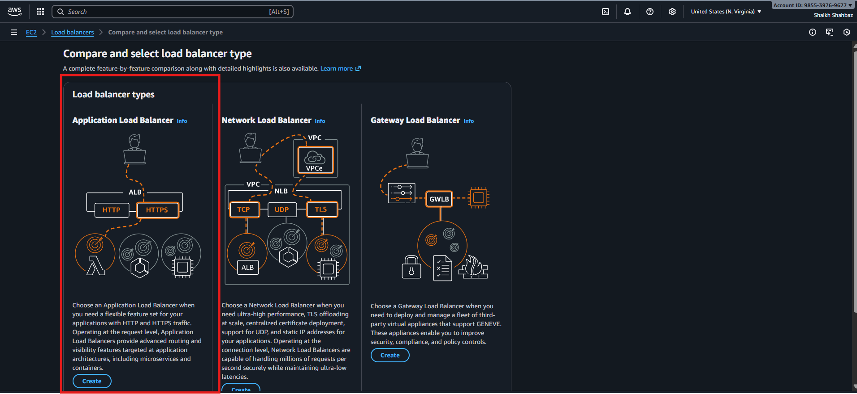

**Actions:**

* **Name: application-lb-demo**
* **Scheme: Internet-facing**
* **IP Type: IPv4**
* **Select at least 2 subnets**
* **Security Group: Allow HTTP (80)**

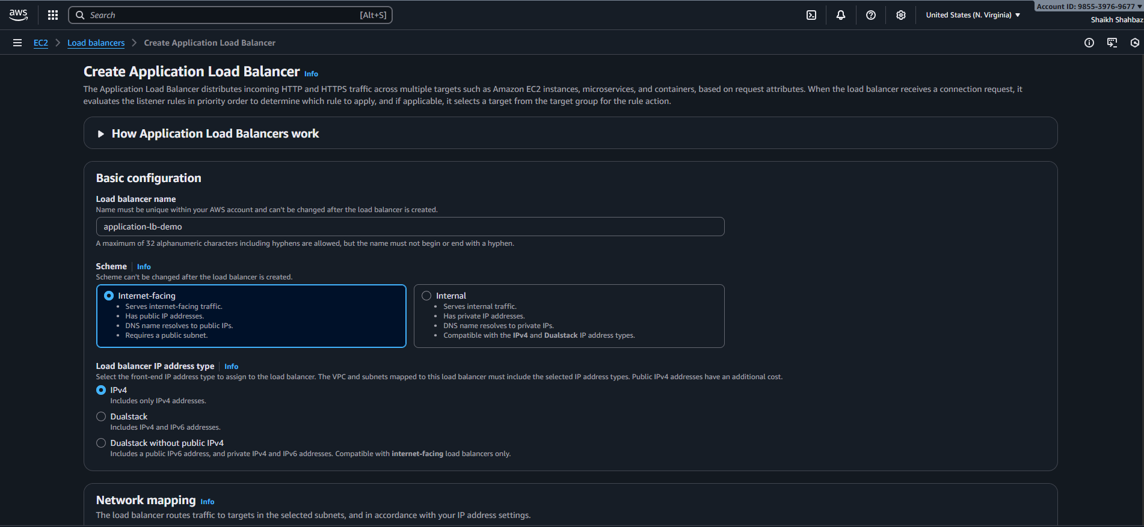

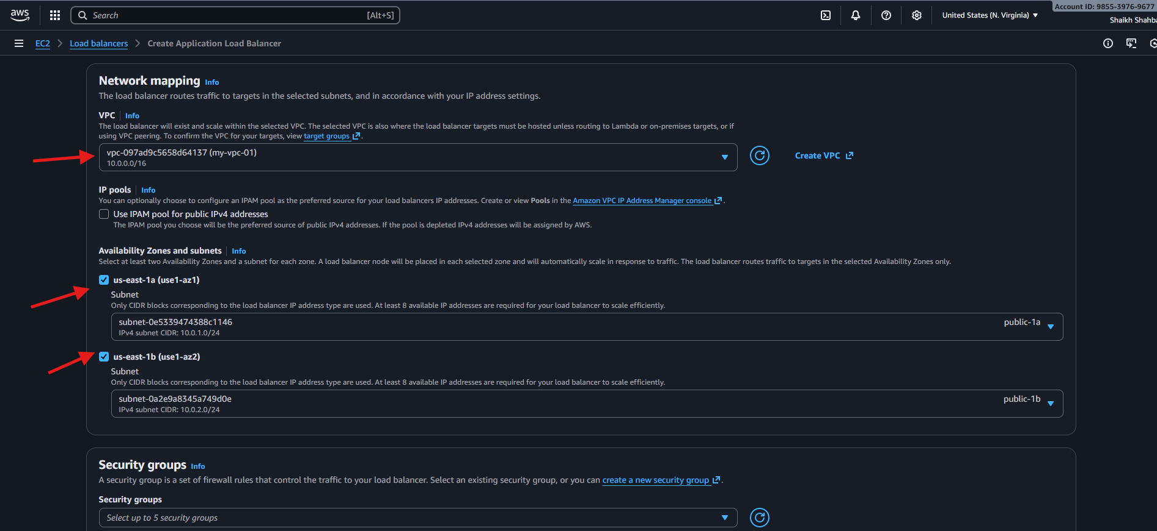

**Listener Configuration:**

* **Listener: HTTP:80**
* **Action: Forward to Target Group created in Step 2**

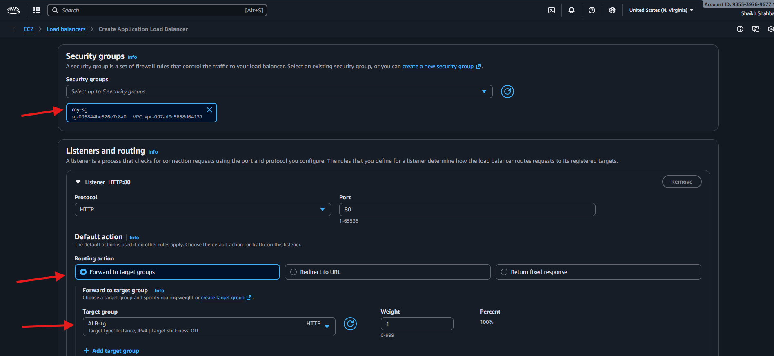

**Evidence:**

* **ALB state: Provisioning → Active**
* **Screenshot: ALB details page showing DNS name**

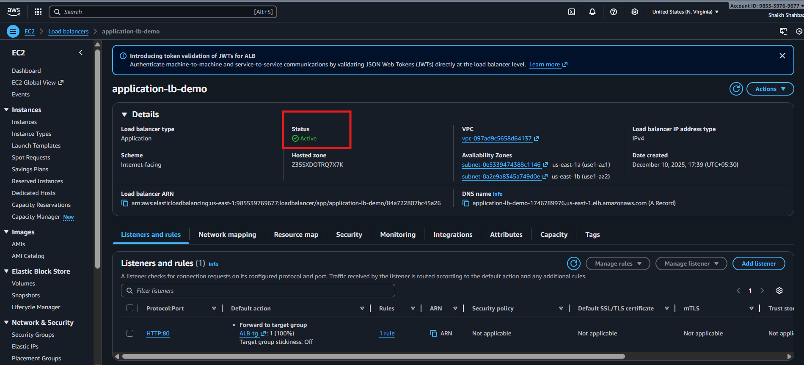

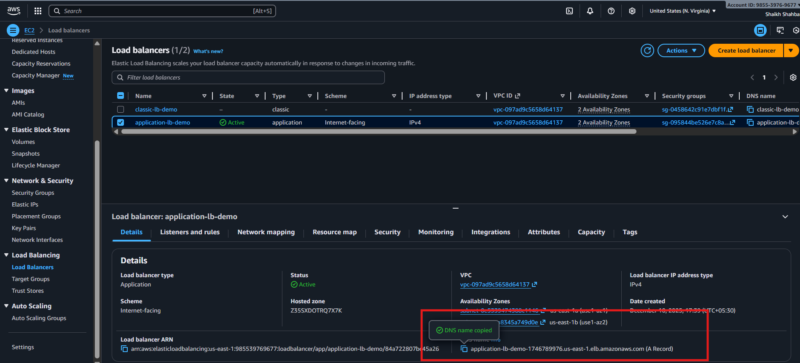

**Step 4: Validate Health Checks**

**Console Path:**

**Target Groups → Your TG → Targets**

**Actions:**

* **Ensure status = healthy**

**Evidence:**

* **Green “Healthy” status for both instances**



**Step 5: Test ALB**

**Actions:**

* **Copy ALB DNS name:**

**http://my-app-alb-123456.region.elb.amazonaws.com**

* **Open in browser**
* **Refresh multiple times to see responses from Instance A and B**

**Expected Output:**

* **“Server ip-xx-xx-xx-xx responding through ALB”**
* **Response switching between instance A & B → load balancing confirmed**

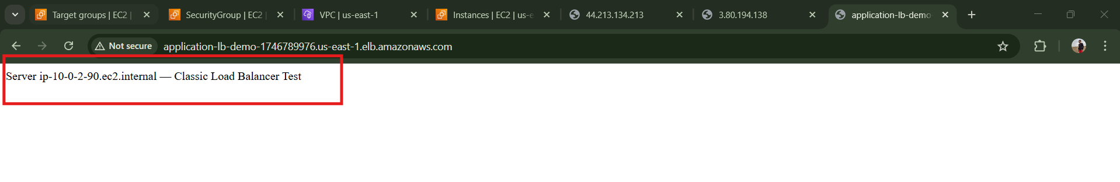

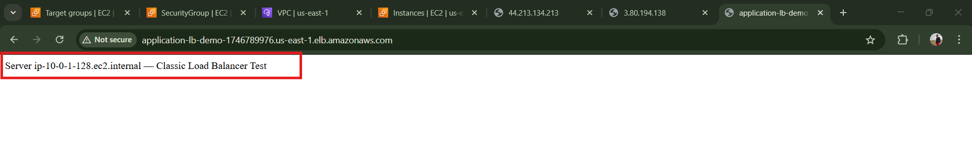

**Validation Steps (With Evidence)**

**Validation 1: Resource Health**

* **EC2 instances Running**
* **Status checks = 2/2 passed**

**Evidence: EC2 instance screenshot**

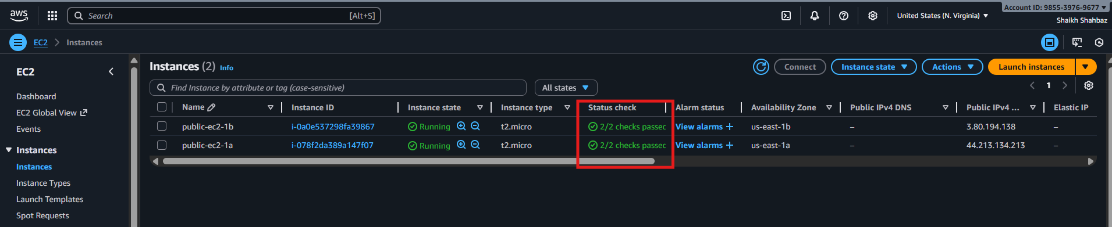

**Validation 2: Load Balancer Health**

* **ALB state: Active**
* **Target health: Healthy**

**Evidence: Target group screenshot**

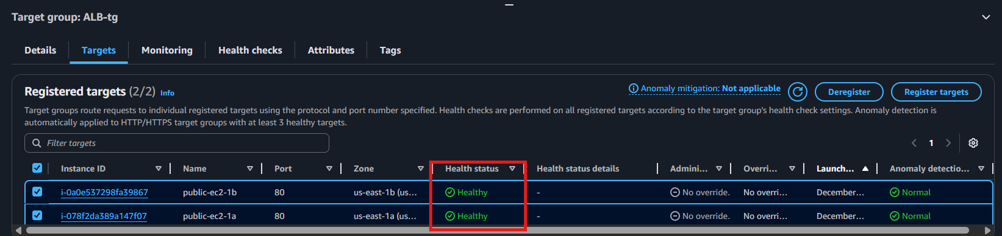

**Validation 4: Network Check**

**From EC2:**

**ping google.com**

**curl amazon.com**

**This confirms outgoing internet and routing.**

**Evidence: Terminal screenshot**

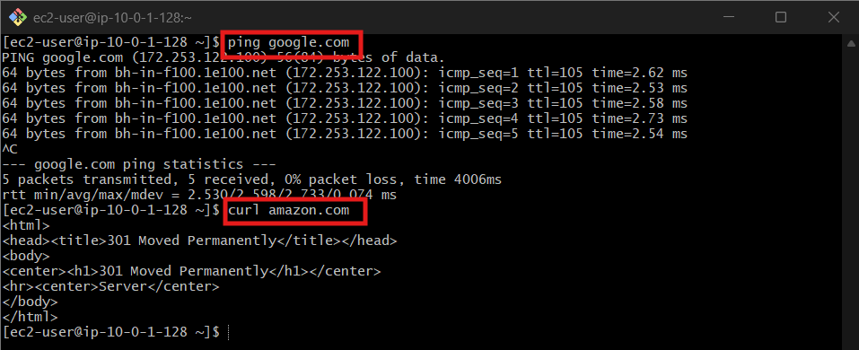

**Issues Faced**

**Issue: Target group shows *unhealthy*  
Fix:**

* **Ensure Apache is running**
* **Security group allows port 80**
* **Health check path is /**

**Conclusion**

**Application Load Balancer successfully configured with:  
 Layer 7 routing  
 Working health checks  
 Multiple EC2 targets  
 Verified functional load balancing**

**3.Configure Network Load balancer.**

**Task Title**

**Configure Network Load Balancer (NLB) in AWS**

**Objective**

**Set up a high-performance Layer 4 Network Load Balancer to distribute TCP traffic across EC2 instances with extremely low latency.**

**Prerequisites**

* **VPC (default or custom)**
* **Public Subnets in at least two AZs**
* **EC2 Instances (web server httpd)**
* **Security Groups for EC2 (NLB doesn’t use SGs)**
* **IAM Permissions**
* **Key Pair (avengers.pem)**
* **Route Tables**
* **Packages / AMI (if needed)**
  + **Amazon Linux 2**

**Step-by-Step Implementation (With Evidence)**

**Step 1: Launch EC2 Instances**

**Console Path:  
EC2 → Instances → Launch Instance**

**Actions:**

1. **Choose Amazon Linux 2 AMI**
2. **Instance type: t2.micro**
3. **Select 2 different AZs**
4. **Attach SG allowing port 80**
5. **SSH into each instance and install web server:**

**Command:**

**sudo yum install -y httpd**

**sudo systemctl start httpd**

**echo "Welcome from Instance 1" > /var/www/html/index.html**

**Evidence:**

***Attach EC2 running screenshot*  
 *SSH terminal showing httpd running***

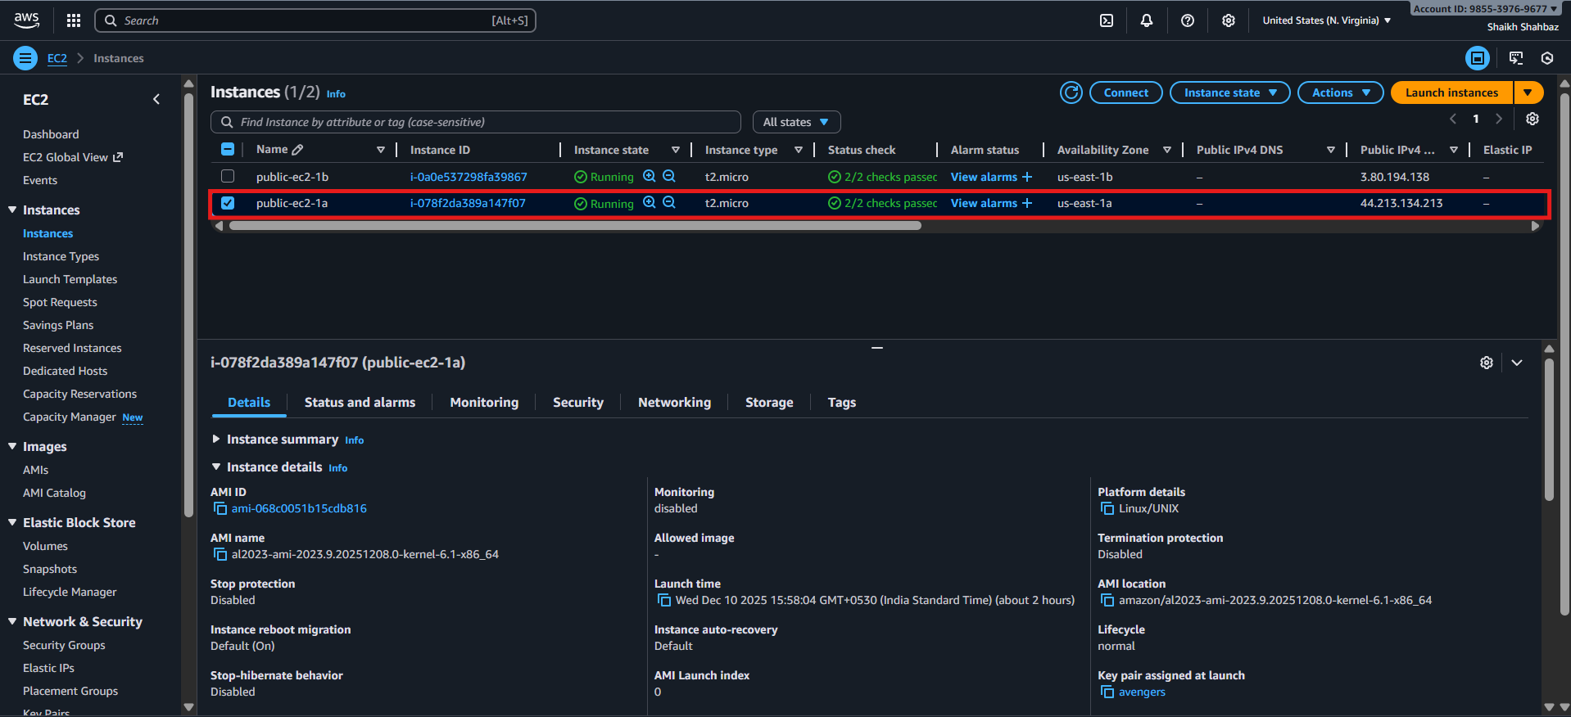

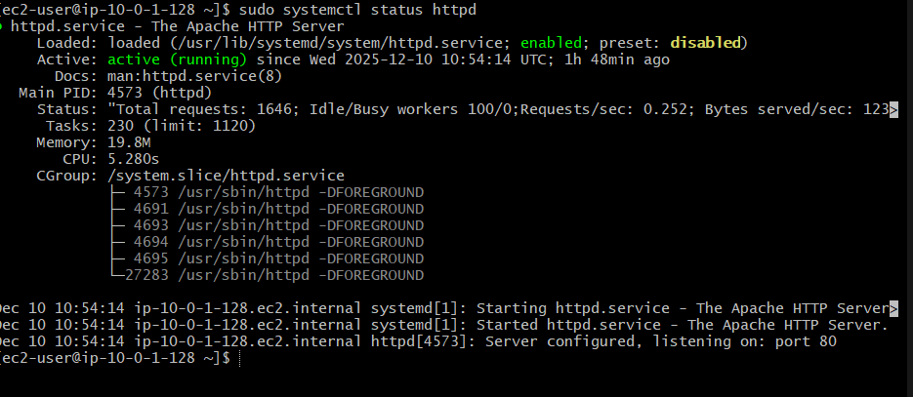

**Step 2: Create Target Group for NLB**

**Console Path:  
EC2 → Target Groups → Create Target Group**

**Actions:**

* **Target Type: Instances**
* **Protocol: TCP**
* **Port: 80**
* **Health check protocol: TCP**
* **Register the 2 EC2 instances**

**Evidence:**

***Target group “healthy” screenshot***

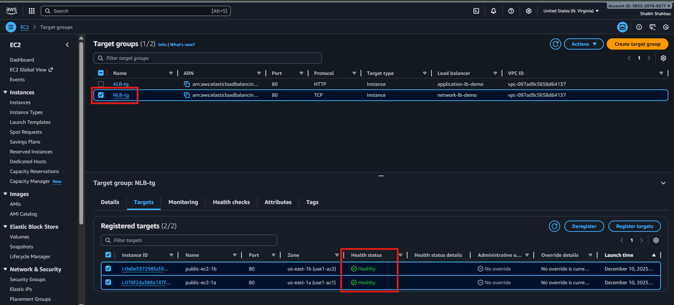

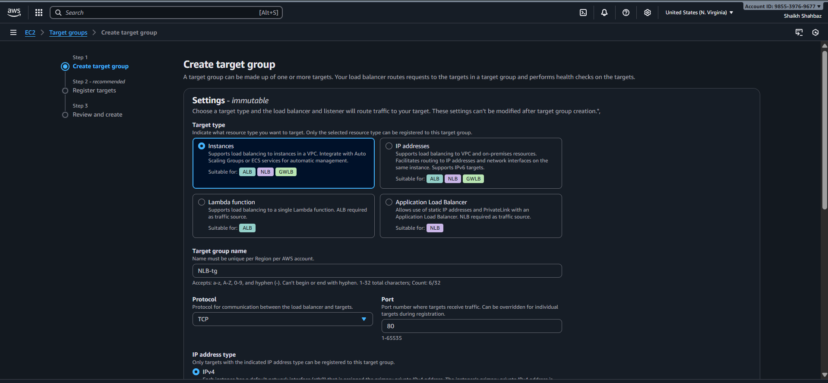

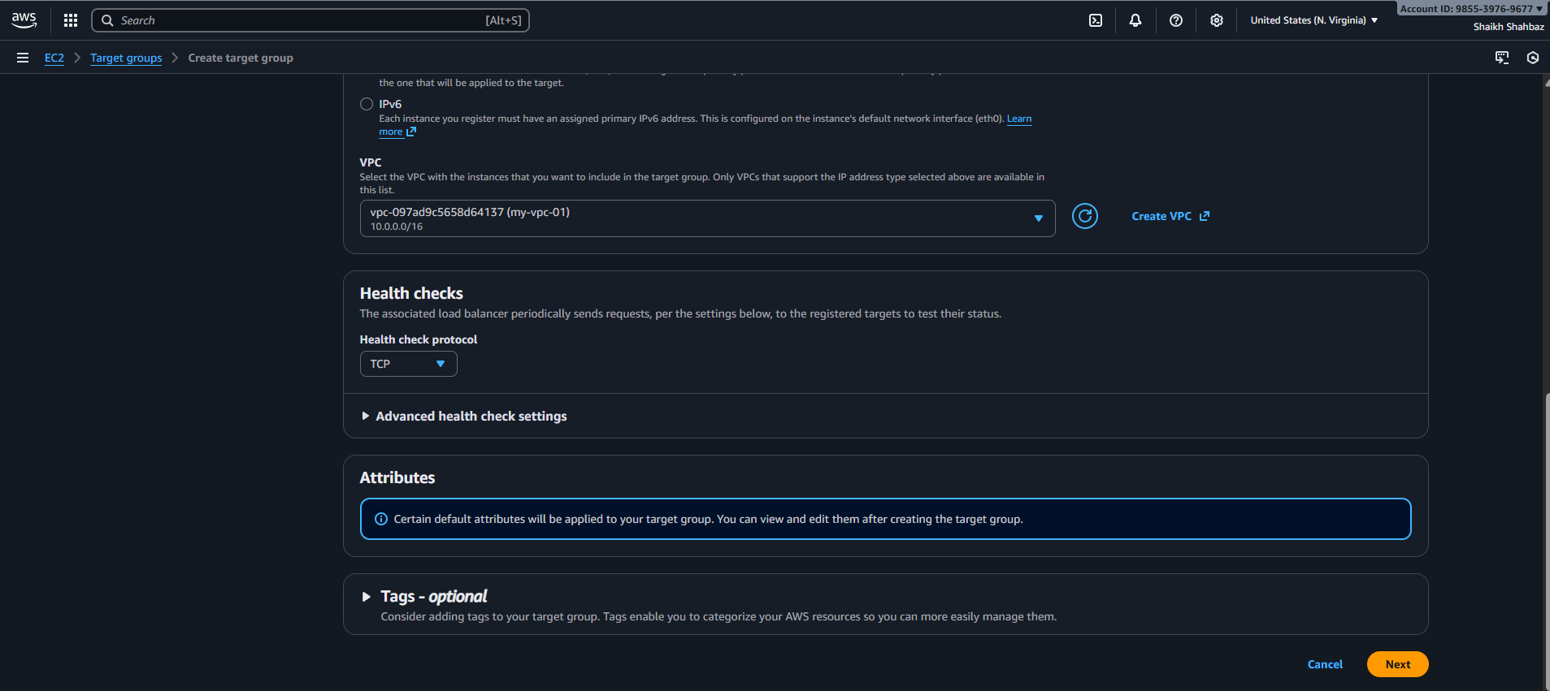

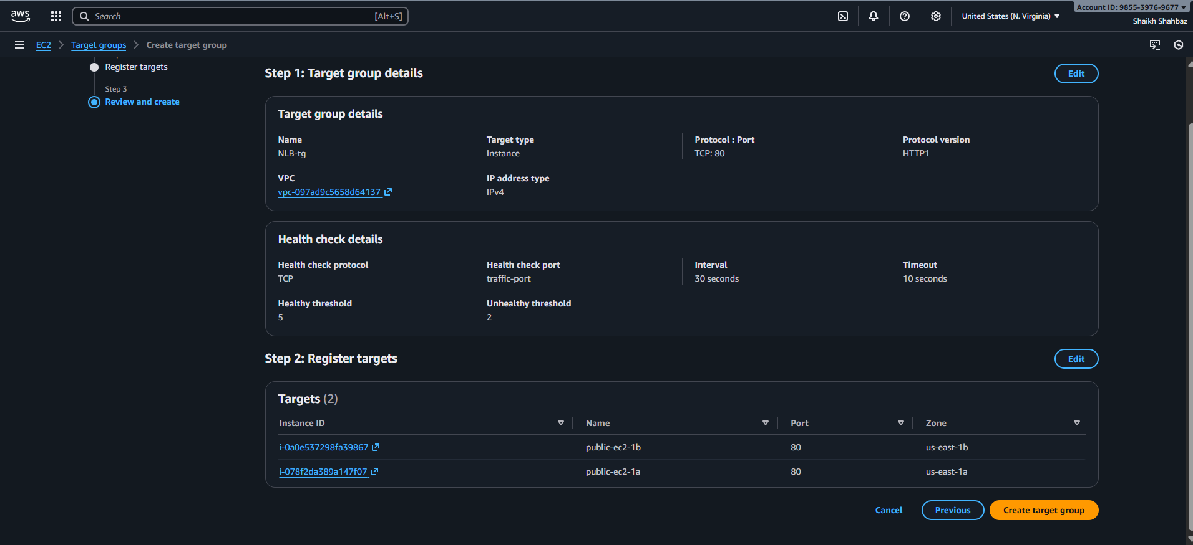

**Step 3: Create Network Load Balancer**

**Console Path:  
EC2 → Load Balancers → Create Load Balancer → Network Load Balancer**

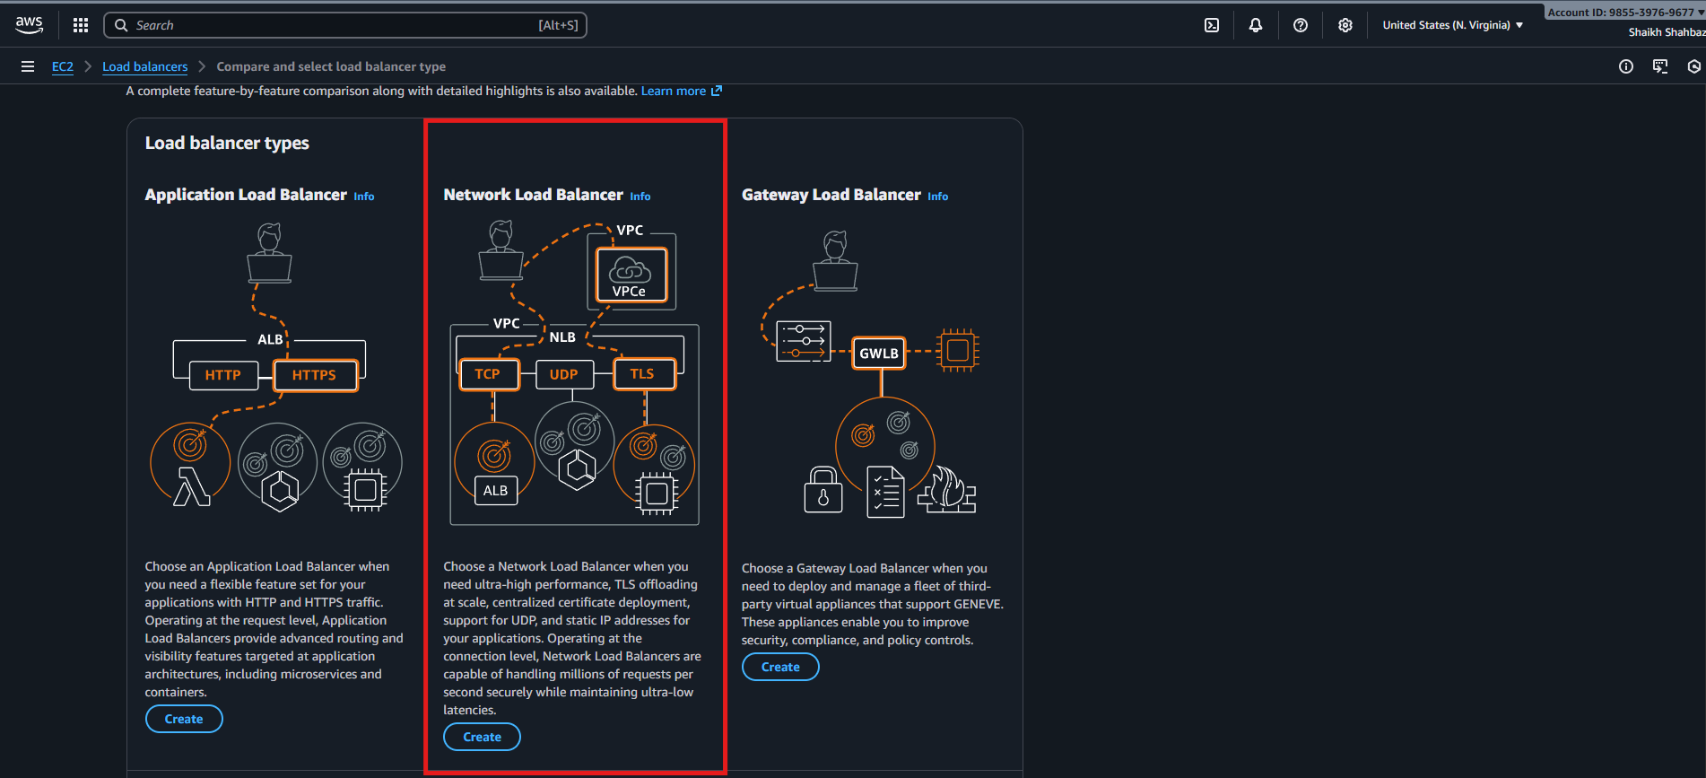

**Actions:**

* **Name: network-lb-demo**
* **Scheme: Internet-facing**
* **Select at least two public subnets**
* **Listener configuration:**
  + **TCP : 80 → Target Group created earlier**

**Evidence:**

***NLB creation screen*  
 *Listener configuration screenshot***

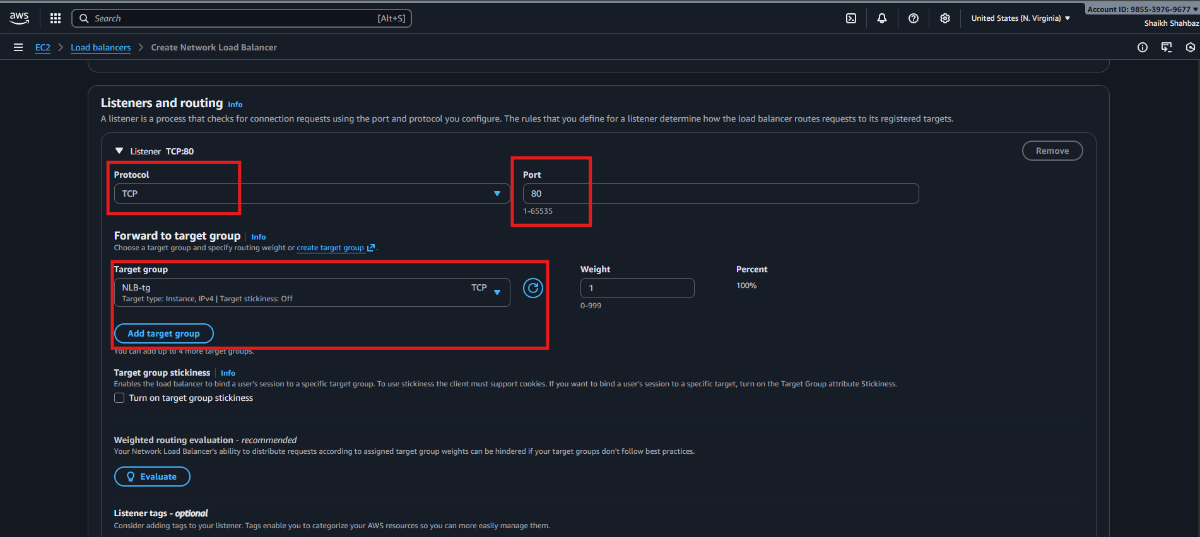

**Step 4: Register Target Group to Listener**

* **Under Listeners → Forward to target group**
* **Select your created target group**

**Evidence:**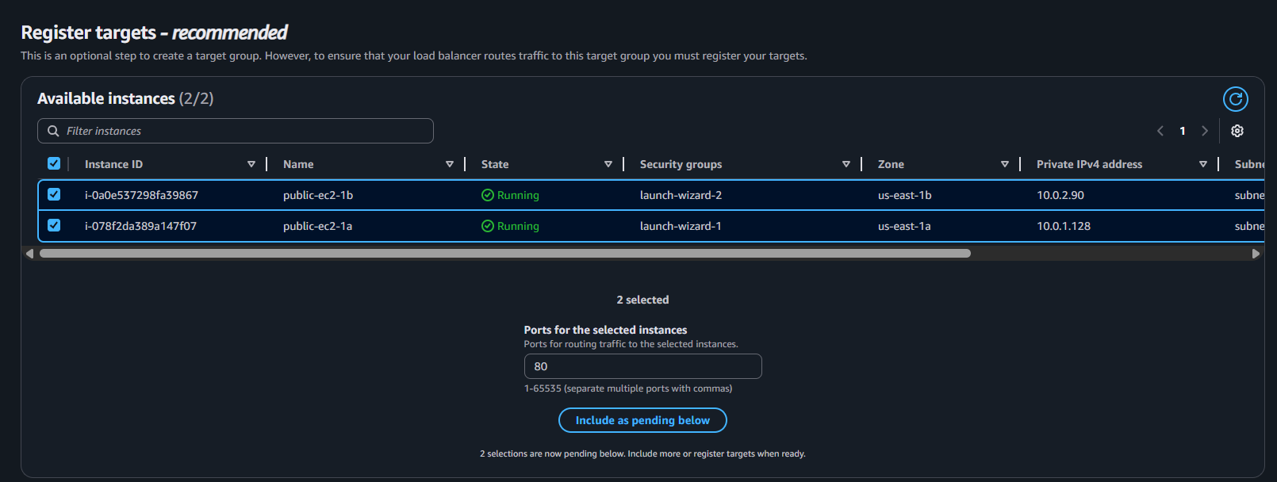



**Step 5: NLB Deployment Completion**

**Wait 1–2 minutes until NLB status becomes:**

**✔ active  
✔ healthy targets**

**Evidence:**

***NLB status: active*  
*Healthy targets view***

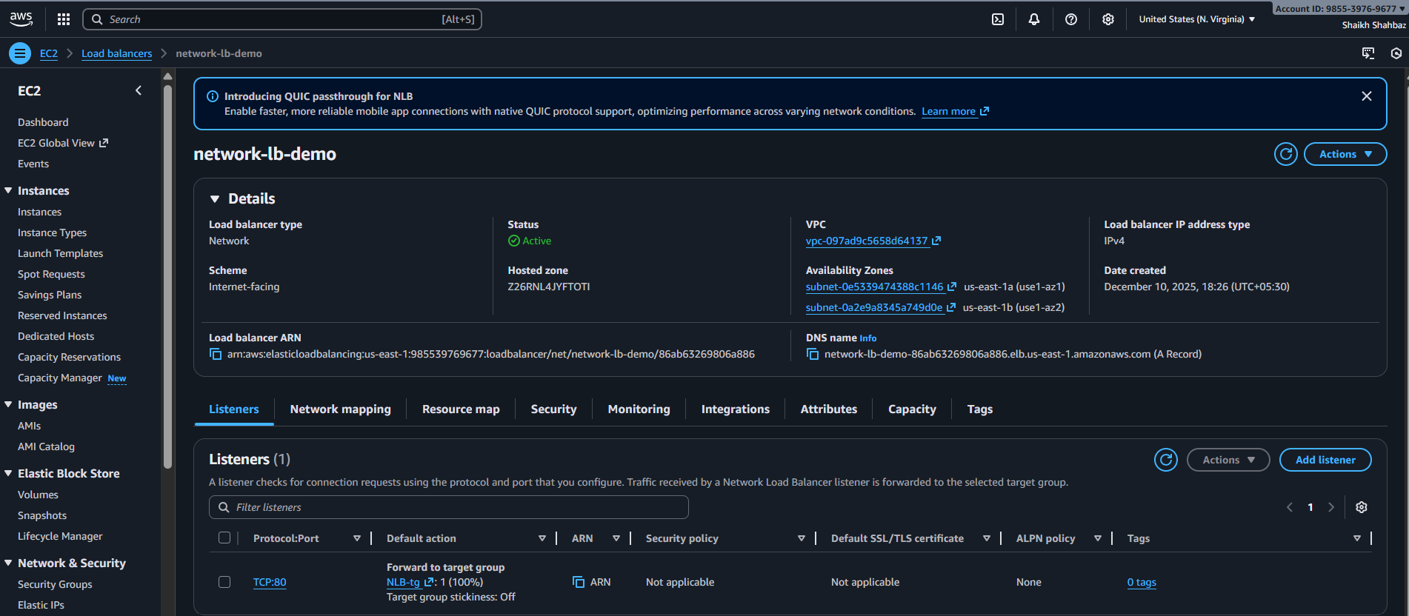

**Validation Steps**

**Validation 1: Resource Health**

**Check:**

* **Both EC2 instances are healthy under Target Group**
* **NLB status is active**

**Evidence:**

**Screenshot of "healthy" target status**



**Validation 2: Functional Check**

**Check:**

**Access NLB DNS name:**

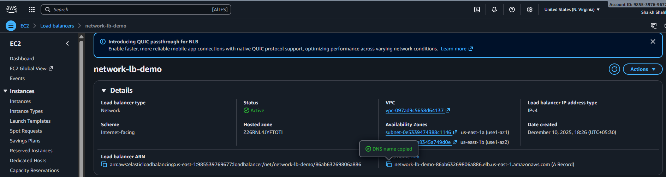

**http://** **network-lb-demo-86ab63269806a886.elb.us-east-1.amazonaws.com**

**Refresh multiple times → responses alternate between:**

* **“Welcome from Instance 1”**
* **“Welcome from Instance 2”**

**Evidence:**

**Browser screenshot showing output from different instances**

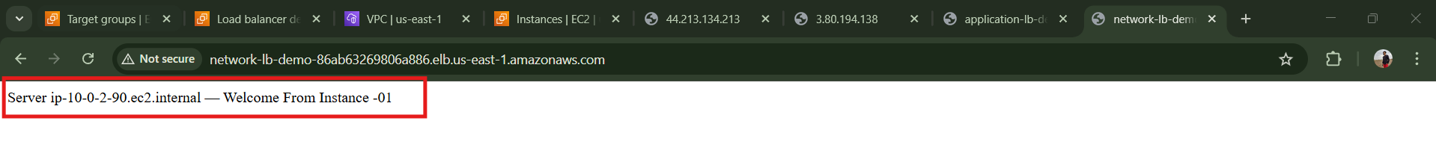

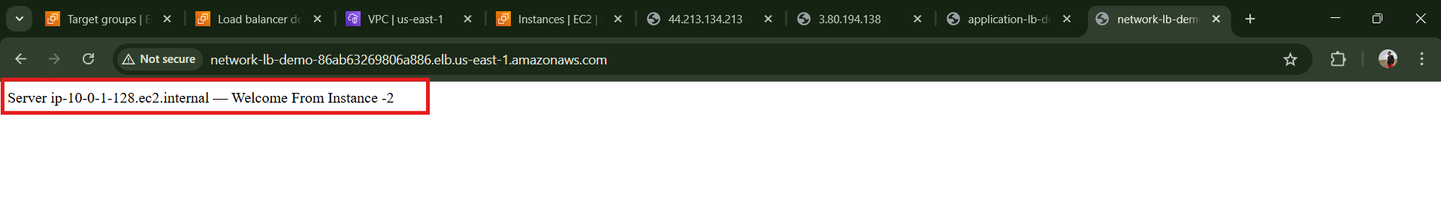

**Validation 3: Network Check**

**From instance, verify web server is responding:**

**curl localhost**

**Expected Output:**

**Welcome from Instance 1**

**Evidence:**

**Terminal output screenshot**



**Issues Faced (Optional)**

| **Issue** | **Fix** |
| --- | --- |
| **Health check failing** | **Ensure port 80 is open in EC2 SG** |
| **Instances remain unhealthy** | **Use TCP health checks instead of HTTP** |
| **No response from NLB** | **Verify subnets are public + route table has IGW** |

**Conclusion**

**You have successfully configured a Network Load Balancer that:  
 Operates on Layer 4 (TCP)  
 Handles massive throughput  
 Distributes traffic across multiple AZs  
 Provides high availability + low latency**

**4.Attach SSL for application load balancer.**

**Task Title**

**Attach SSL Certificate to an Application Load Balancer (HTTPS Listener Configuration)**

**Objective**

**Enable secure encrypted communication (HTTPS) on an Application Load Balancer using an SSL/TLS certificate issued by AWS Certificate Manager (ACM).**

**Prerequisites**

**Before starting, ensure the following:**

* **VPC**
* **Public Subnets (at least 2 for ALB)**
* **Application Load Balancer already created**
* **Target Group created and attached**
* **Domain Name (shaikhshahbazz.online)**
* **Hosted Zone in Route 53**
* **ACM Certificate (Pending or Issued)**
* **Security Group allowing port 443**
* **IAM permissions for ACM + ELB**

**Step-by-Step Implementation**

**Step 1: Request SSL Certificate in ACM**

**Console Path:  
AWS Console → Certificate Manager → Request Certificate → Request Public Certificate**

**Actions:**

* **Enter domain name (e.g., www.shahbazz.com)**
* **Select DNS Validation**
* **Confirm**

**Evidence (Expected Screenshot):**

* **ACM shows certificate status Pending validation**

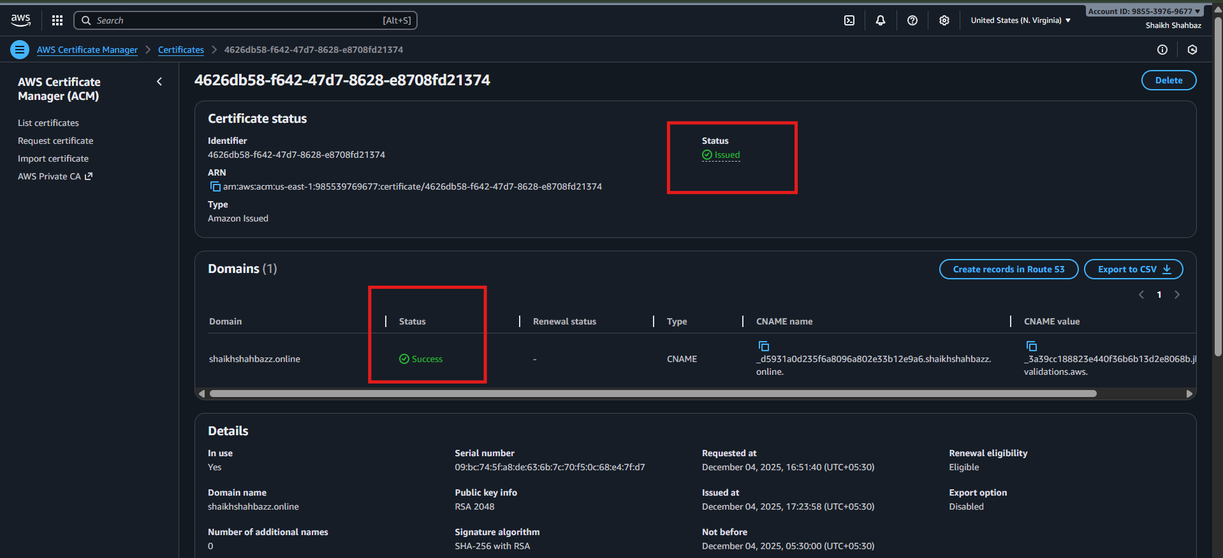

**Step 2: Validate the SSL Certificate (DNS Validation)**

**Console Path:  
ACM → Your Certificate → Create CNAME Record in Route 53**

**Actions:**

* **Click *Create Record in Route 53***
* **Wait 1–5 mins**

**Evidence:**

* **Status changes to Issued**

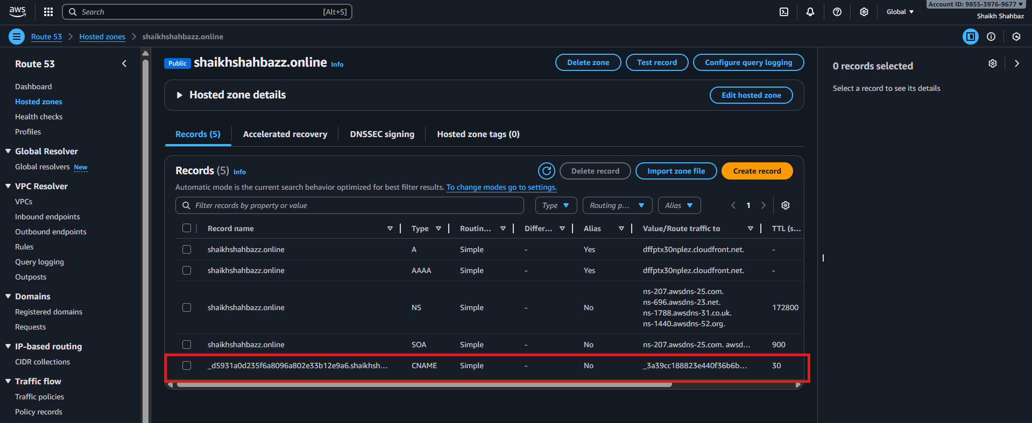

**Step 3: Open ALB Listener Settings**

**Console Path:  
EC2 → Load Balancers → Select ALB → Listeners**

**Actions:**

* **Click Add Listener**
* **Choose:**
  + **Protocol: HTTPS**
  + **Port: 443**

**Evidence:**

* **HTTPS listener creation pop-up visible**

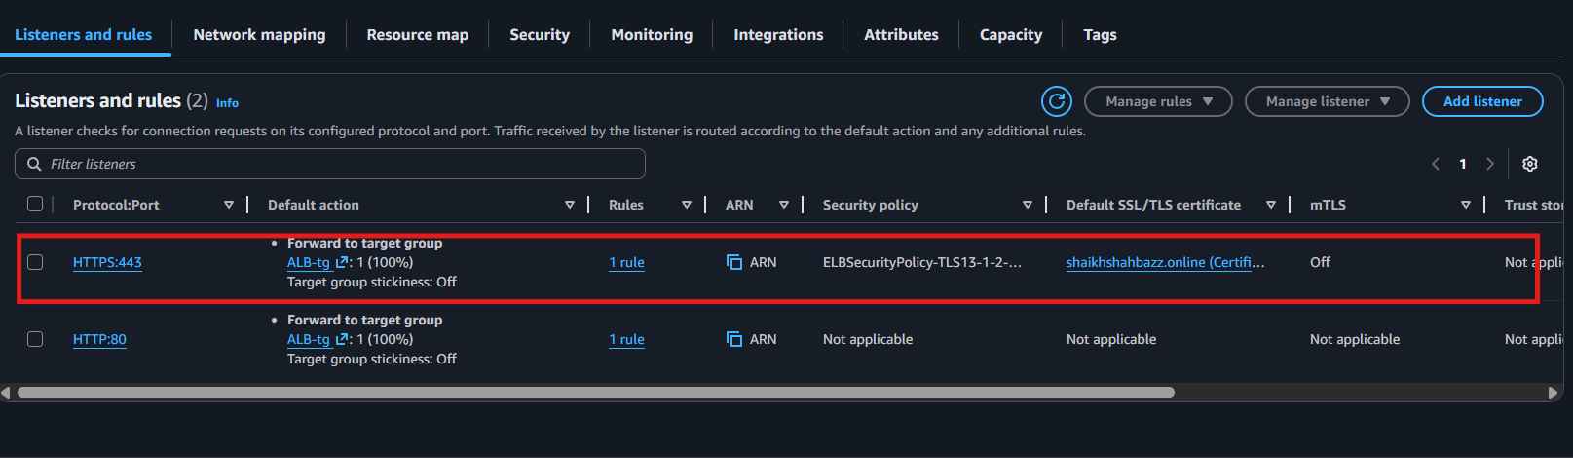

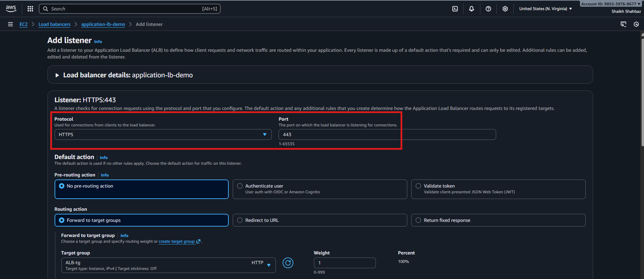

**Step 4: Attach SSL/TLS Certificate**

**Console Path:  
When adding HTTPS listener ↓  
→ Choose ACM Certificate  
→ Select: *.shahbazz.com**

**Actions:**

**Forward to: Existing Target Group**

**Evidence:**

* **Certificate attached under HTTPS listener**

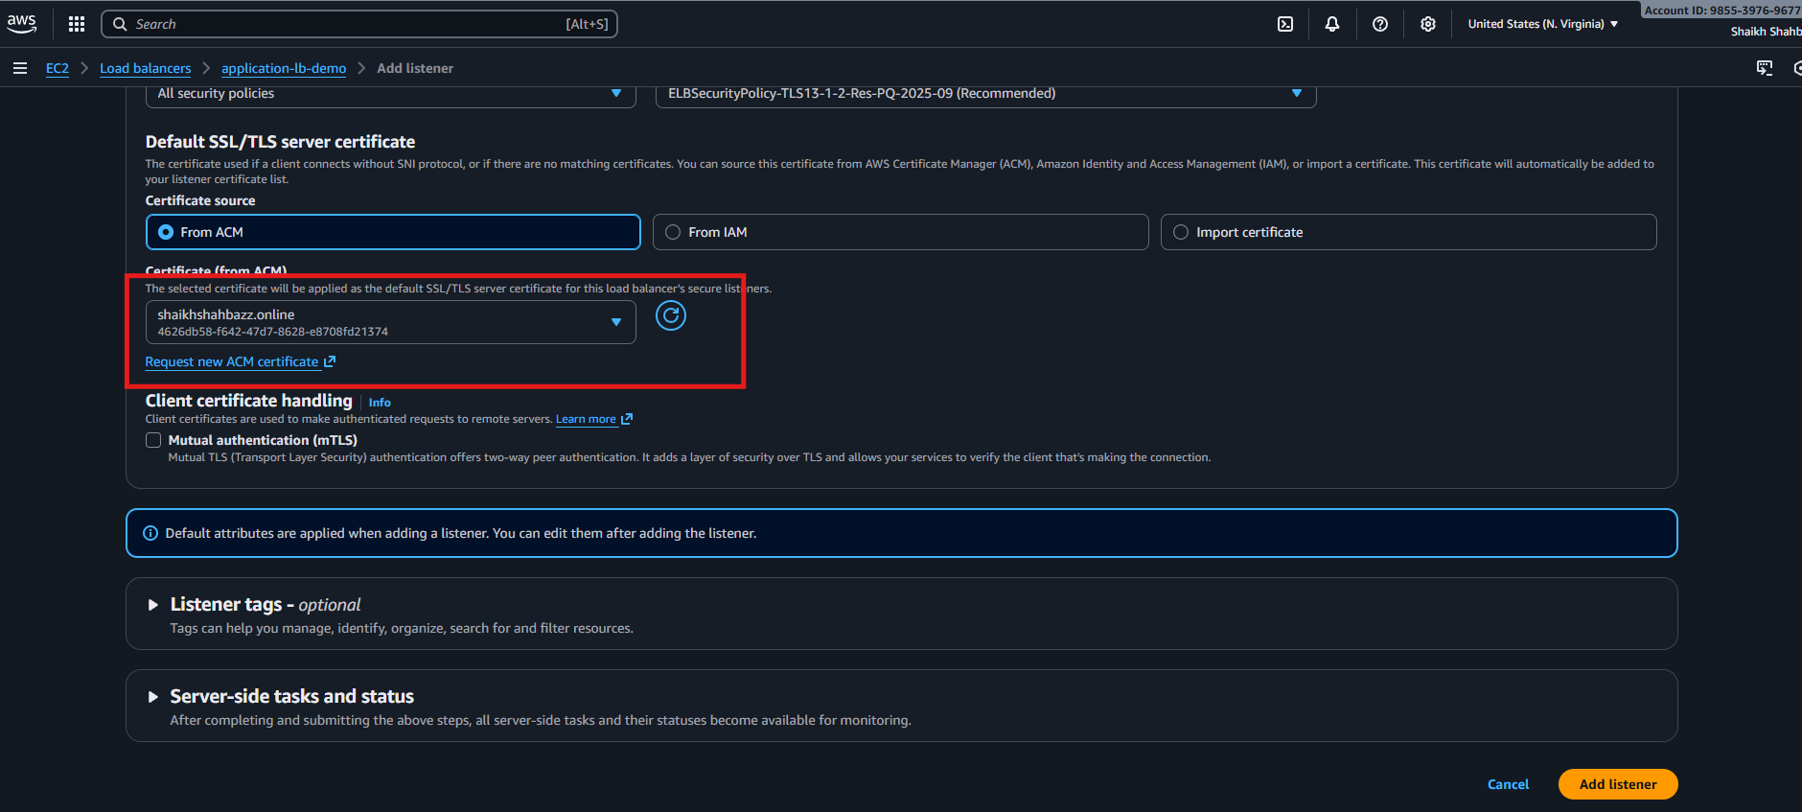

**Step 5: Update Security Group for ALB**

**Console Path:  
EC2 → Load Balancers → Select ALB → Security**

**Actions:**

* **Allow Inbound 443 from 0.0.0.0/0**

**Evidence:**

* **Security group rule visible: 443 open**

**Validation Steps**

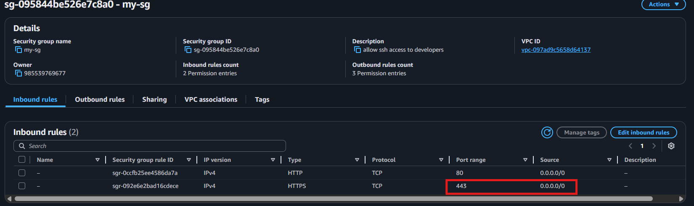

**Validation 1: Certificate Status**

**Check ACM certificate shows Issued.**

**Evidence:  
Screenshot of ACM certificate status = Issued.**

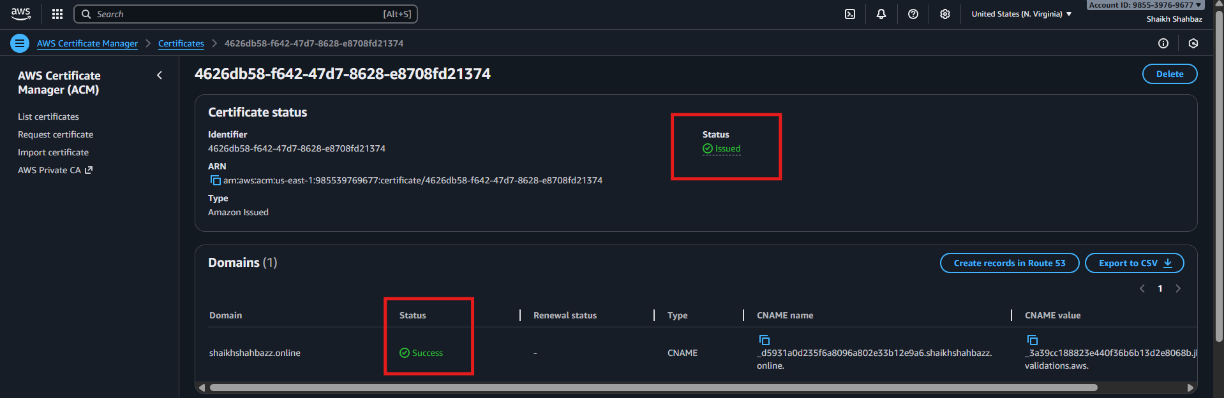

**Validation 2: HTTPS Listener Active**

**Go to ALB → Listeners → verify:**

**HTTPS : 443 → healthy target group**

**Evidence:  
Listener tab showing HTTPS**

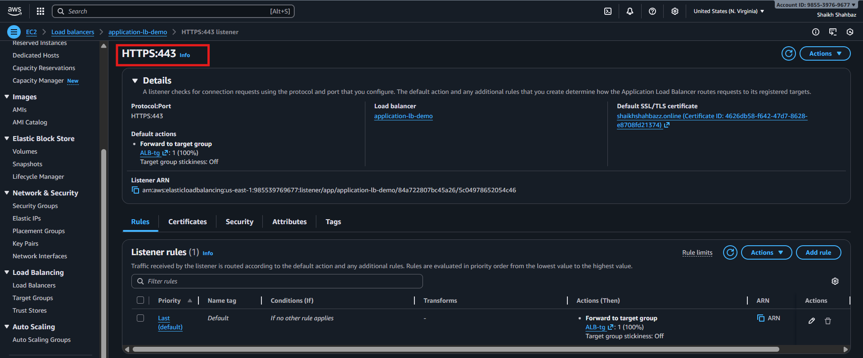

**Validation 3: Open Website Using HTTPS**

**Open:**

**https://www.shahbazz.online**

**Expected Result:**

* **Page loads**
* **Browser shows “Secure” padlock icon**

**Evidence:  
Screenshot of secure (HTTPS) website page.**

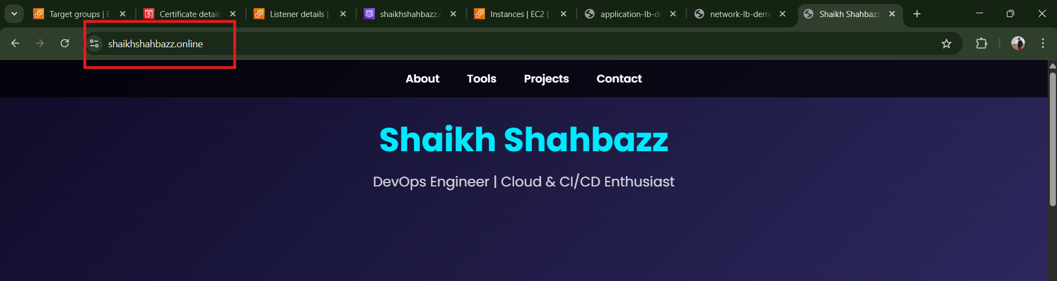

**Issues Faced (Optional)**

**Issue: Certificate stuck in “Pending Validation”  
Fix: Ensure Route 53 DNS automatically added the CNAME record correctly.**

**Issue: HTTPS not opening  
Fix: Open port 443 in ALB security group.**

**Conclusion**

**You successfully configured SSL/TLS on your Application Load Balancer, securing your application with HTTPS and ensuring encrypted traffic from users to the ALB.**

**5.Map Application load balancer to R53.**

**Task Title**

**Map Application Load Balancer to Route 53 Hosted Zone**

**Objective**

**Point a custom domain (example: www.shahbazz.com) to the ALB DNS using Route 53 so users can access the application through a clean domain instead of the long ALB hostname.**

**Prerequisites**

* **VPC**
* **Public Subnets (ALB must exist in at least 2 AZs)**
* **Application Load Balancer (already created)**
* **Target Group attached to ALB**
* **Route 53 Hosted Zone (Domain registered in Route 53 or external domain with NS mapped)**
* **Security Groups**
* **IAM Permissions for Route 53, ELB**
* **SSL Certificate (optional if HTTPS used)**

**Step-by-Step Implementation**

**Step 1: Identify ALB DNS Name**

**Console Path:  
EC2 → Load Balancers → Select your ALB → Description tab**

**Example ALB DNS:**

**application-lb-demo-1746789976.us-east-1.elb.amazonaws.com**

**Explanation:  
This DNS name will be mapped in Route 53.**

**Evidence:  
 *Screenshot Placeholder*  
(Shows ALB description with DNS name highlighted)**

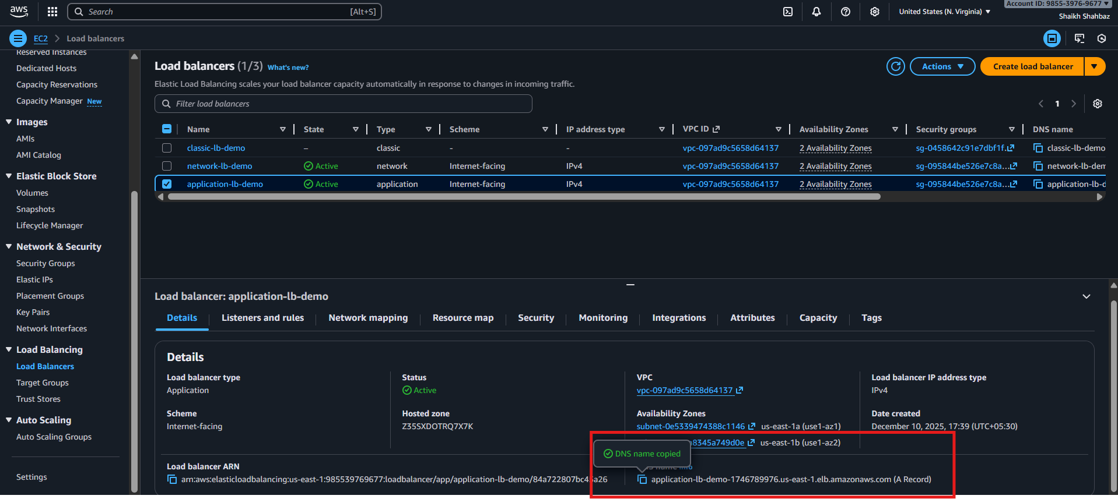

**Step 2: Open Route 53 Hosted Zone**

**Console Path:  
Route 53 → Hosted Zones → Select domain ( shaikhshahbazz.online)**

**Explanation:  
We will create an alias A-Record pointing to ALB.**

**Evidence:  
*Screenshot Placeholder*  
(Hosted Zone records list visible)**

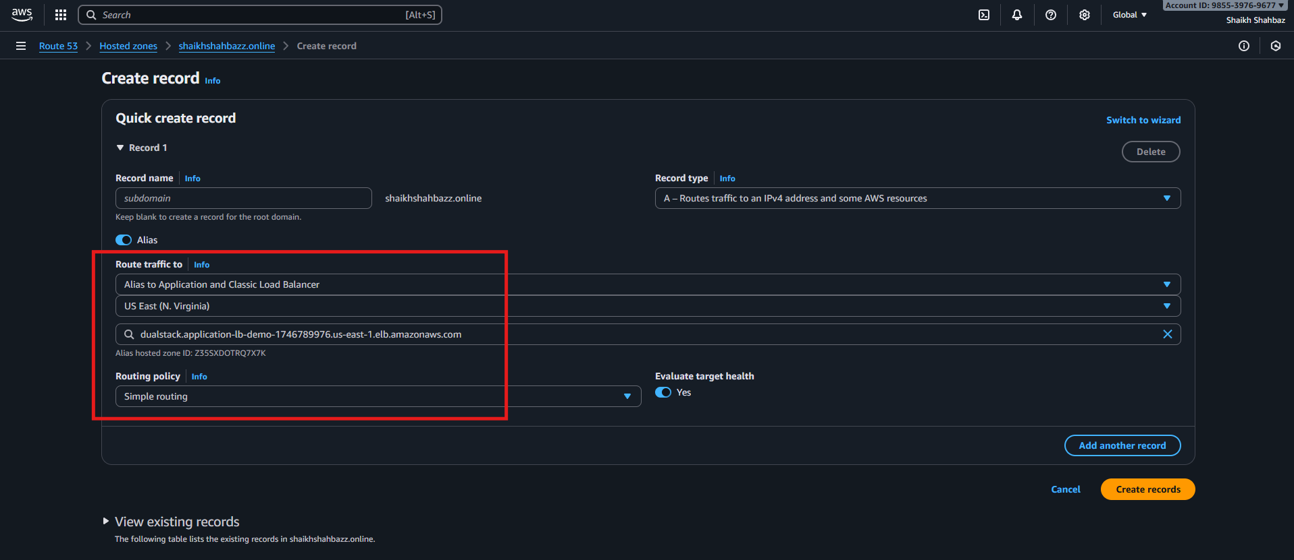

**Step 3: Create A Record (Alias to ALB)**

**Console Path:  
Hosted Zone → Create Record**

**Fill values:**

| **Field** | **Value** |
| --- | --- |
| **Record Name** | **www (or blank for root domain)** |
| **Record Type** | **A (IPv4 Address)** |
| **Alias** | **Yes** |
| **Alias Target** | **Select ALB from dropdown** |
| **Routing Policy** | **Simple** |
| **Evaluate Target Health** | **Yes** |

**Explanation:  
Route 53 automatically resolves the ALB alias target—even if AWS changes the ALB IP internally.**

**Evidence:  
 *Screenshot Placeholder*  
(Record creation screenshot showing ALB selected)**



**Step 4: Save the Record**

**Click Create Records.**

**Explanation:  
The domain will now resolve to the ALB.**

**Evidence:  
*Screenshot Placeholder*  
(Record successfully created)**

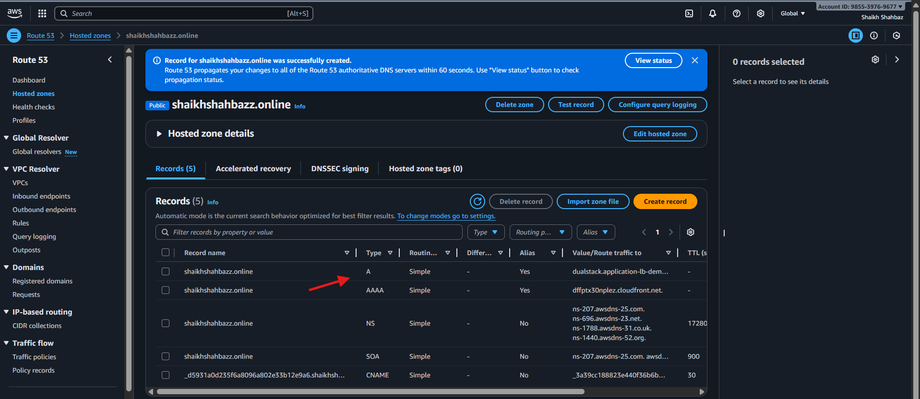

**Validation Steps (Mandatory, With Evidence)**

**Validation 2: Browser Test**

**Open:**

**http://www.shahbazz.com**

**OR if SSL attached:**

**https://www.shahbazz.com**

**Expected Result:  
Application loads from EC2 via ALB.**

**Evidence:  
 *Browser screenshot placeholder***

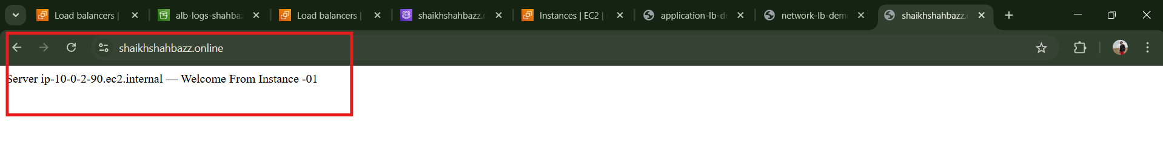

**Issues Faced (Optional)**

| **Issue** | **Cause** | **Fix** |
| --- | --- | --- |
| **ALB not appearing in Route 53** | **ALB not in same region** | **Use correct region** |
| **Domain not resolving** | **DNS propagation delay** | **Wait 1–5 minutes** |
| **Browser shows error** | **SG/Listener misconfig** | **Allow port 80/443 properly** |

**Conclusion**

**You successfully mapped the Application Load Balancer to Route 53, enabling your application to be accessed through a clean custom domain. This improves user experience and supports HTTPS setups and global traffic routing.**

**6.Push the application load balancer logs to S3**

**Task Title**

**Enable and Store Application Load Balancer (ALB) Access Logs in S3 Bucket**

**Objective**

**Configure ALB access logs to automatically store request data (source IP, target IP, response time, latency) into an S3 bucket for auditing, analysis, and security compliance.**

**Prerequisites**

* **VPC**
* **Public Subnets**
* **Existing Application Load Balancer**
* **S3 bucket created for logs**
* **Correct bucket policy for ELB logging**
* **IAM Permissions:**
  + **s3:PutObject**
  + **s3:GetBucketPolicy**
  + **elasticloadbalancing:\***
* **Route Tables**
* **Security Groups**

**Step-by-Step Implementation (With Evidence)**

**Step 1: Create an S3 Bucket for ALB Logs**

**Console Path**

**S3 → Create bucket**

**Configuration**

* **Bucket name: alb-logs-shahbazz**
* **Region: same as ALB**
* **Block Public Access: Enabled**
* **Versioning: optional**
* **Encryption: Enabled (AES-256)**

**Evidence:**

***(Add screenshot here)*  
S3 bucket creation screen.**

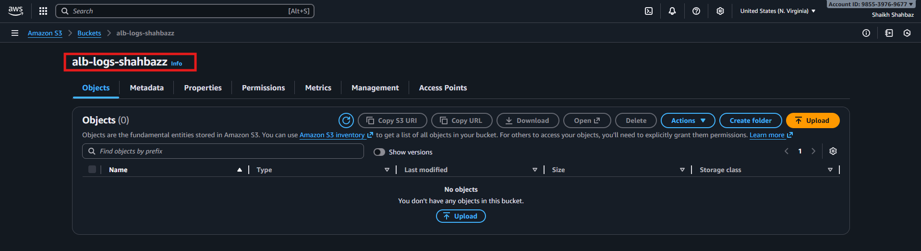

**Step 2: Attach AWS-Required Bucket Policy for ALB Logging**

**Console Path**

**S3 → Bucket → Permissions → Bucket Policy → Edit**

**Policy (replace bucket name + region + account ID)**

**{**

**"Version": "2012-10-17",**

**"Statement": [**

**{**

**"Sid": "AWSALBAccessLogs",**

**"Effect": "Allow",**

**"Principal": {**

**"Service": "logdelivery.elasticloadbalancing.amazonaws.com"**

**},**

**"Action": "s3:PutObject",**

**"Resource": "arn:aws:s3:::alb-logs-shahbazz/AWSLogs/<ACCOUNT-ID>/*"**

**}**

**]**

**}**

**Explanation**

* **Allows ELB service to upload log files into S3.**

**Evidence:**

***(Add screenshot of bucket policy applied)***

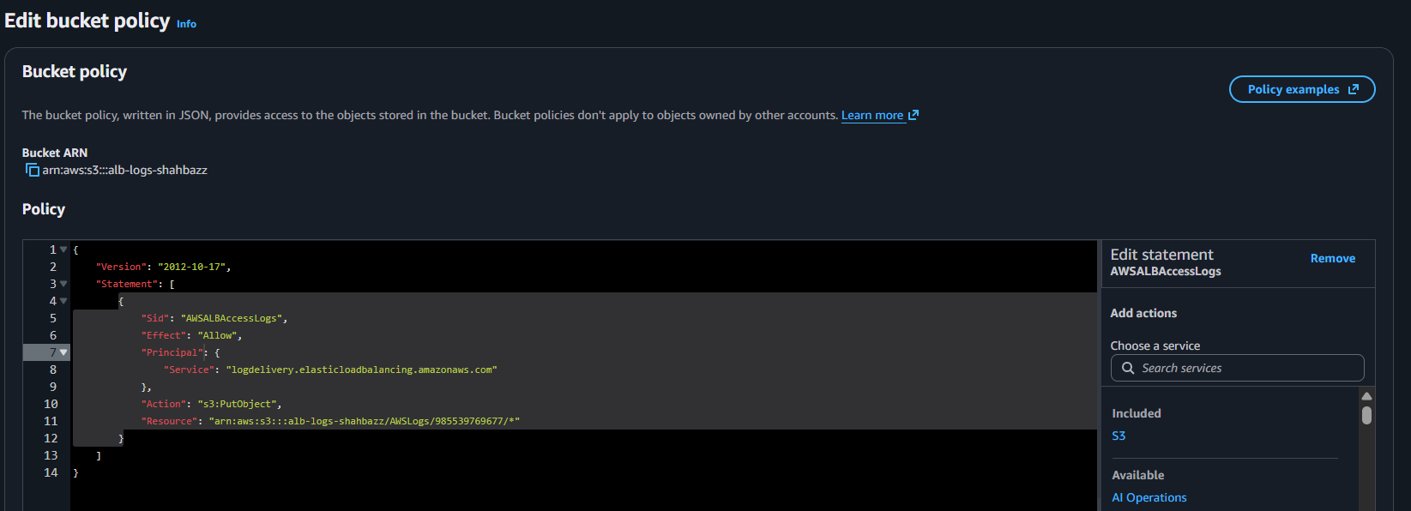

**Step 3: Enable Access Logs on the Application Load Balancer**

**Console Path**

**EC2 → Load Balancers → Select ALB → Attributes**

**Steps**

1. **Scroll to Access Logs**
2. **Click Edit**
3. **Enable Access Logging: ON**
4. **Select S3 bucket: alb-logs-shahbazz**
5. **Prefix (optional): alb/**
6. **Save**

**Explanation**

**This enables the ALB to periodically push logs in gzip format to S3.**

**Evidence:**

***(Screenshot of ALB Access Logs enabled)***

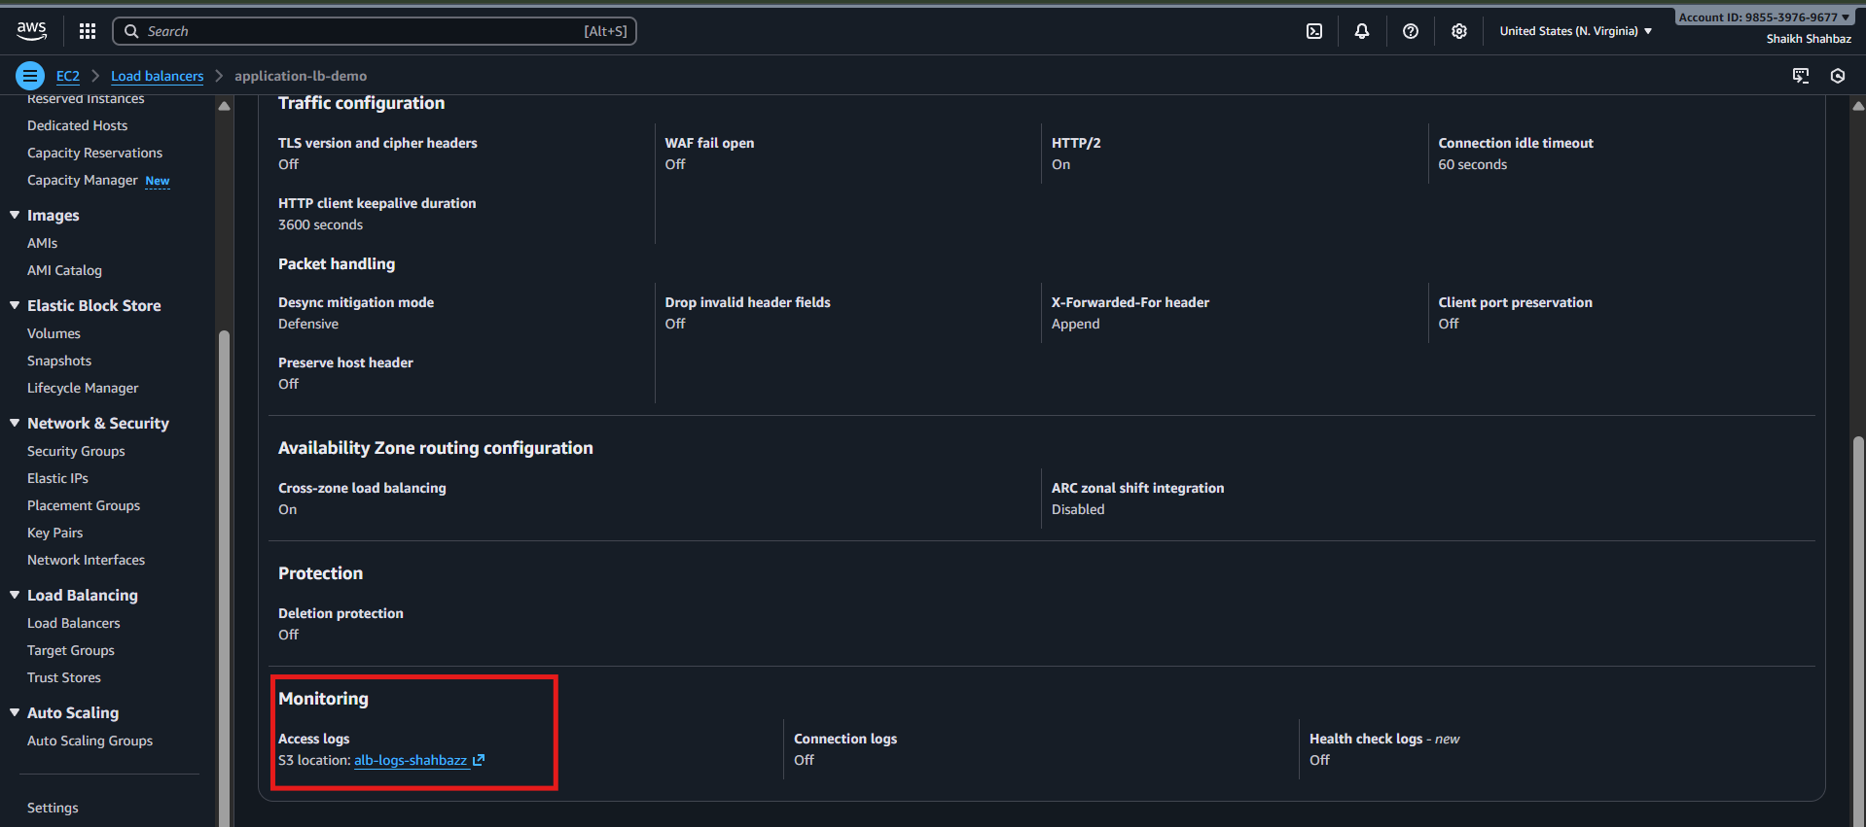

**Step 4: Validation That Logs Are Being Delivered**

**Console Path**

**S3 → alb-logs-shahbazz → AWSLogs → <account-id> → elasticloadbalancing → <region>/**

**What You Should See**

**Files named like:**

**2025-01-10T12-25-59.abc123.log.gz**

**Evidence:**

***(Screenshot of S3 folder containing ALB log files)***

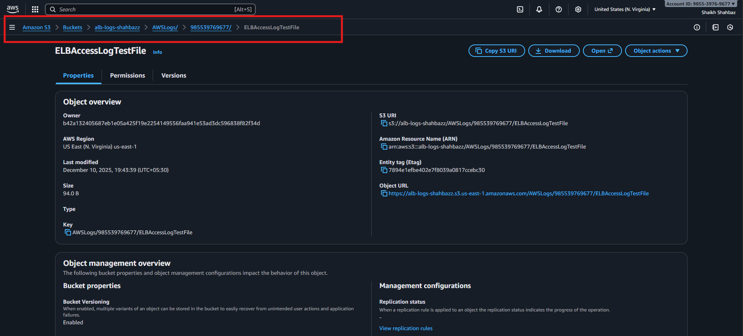

**Validation Steps**

**Validation 2: Confirm S3 Bucket Contains Logs**

**Navigate to:**

**s3://alb-logs-shahbazz/AWSLogs/<account-id>/elasticloadbalancing/<region>/**

**Expected: .log.gz files appear every 5 minutes.**

**Evidence:**

***(Screenshot of log files in S3)***

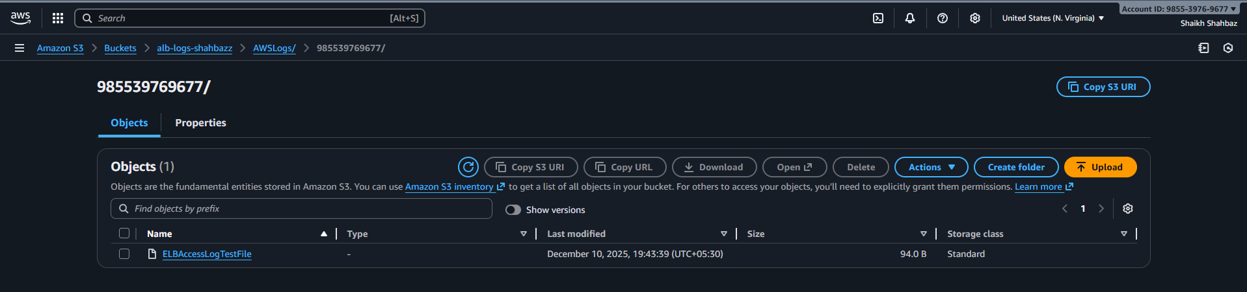

**Issues Faced (Optional)**

**Issue: ELB could not write logs into S3**

**Fix: Bucket policy was missing the correct service principal  
logdelivery.elasticloadbalancing.amazonaws.com**

**Issue: No logs appearing**

**Fix: ALB had no traffic → hit ALB DNS from browser to generate traffic.**

**Conclusion**

**The Application Load Balancer is now successfully configured to push access logs to S3 for monitoring, security analytics, and troubleshooting. Logs are generated every 5 minutes and stored in a structured format for long-term retention and analysis.**